K8S Assignments

Que 1 →

● Create 2 Public Docker Hub registries named cloudethix_master_nginx_yourname & cloudethix_release_nginx_yourname.

● Clone below repository on your system. <https://github.com/zembutsu/docker-sample-nginx.git>

● Initialize a local repository & copy the code from above repo to your local repository in master branch and then create below branches. release main hotfix

● Once code is copied to local repository,from master branch update the index.html and add word "Cloudethix Master Branch Nginx" and build the docker image & add meaningful tags and push to Docker Hub registry cloudethix_master_nginx_yourname.

● Also from release branch update the index.html and add word "Cloudethix Release Branch Nginx" and build the docker image & add meaningful tags and push to Docker Hub registry cloudethix_release_nginx_yourname.

● Once Images are copied to Docker hub registries, switch to the main branch.

● In main branch create directory named kube/clusterIP & inside kube directory create file named master_pod.yaml with pod name master_nginx & with label master_nginx & add image that you have pushed in Docker Hub registry cloudethix_master_nginx_yourname.

● Also create a file release_pod.yaml with pod name release_nginx & with label release_nginx & add image that you have pushed in Docker Hub registry cloudethix_release_nginx_yourname.

● Create a file called cluster_ip-service.yaml with service name cloudethix_clusterip and with Type clusterIP.

● Then, select the pod with label release_nginx in service.

● Create all these three resources in your k8s cluster.

● Now, access master_nginx pod shell & curl the master_nginx pod & check the result.

● Also try to curl release_nginx pod with DNS name & check the result.

● Then curl the clusterip service with its name and check the result.

● Finally, create a GITHUB remote repository named cloudethix-k8s-yourname and push all the branches to the remote repository.

● Take all screenshots and create a well formatted document.

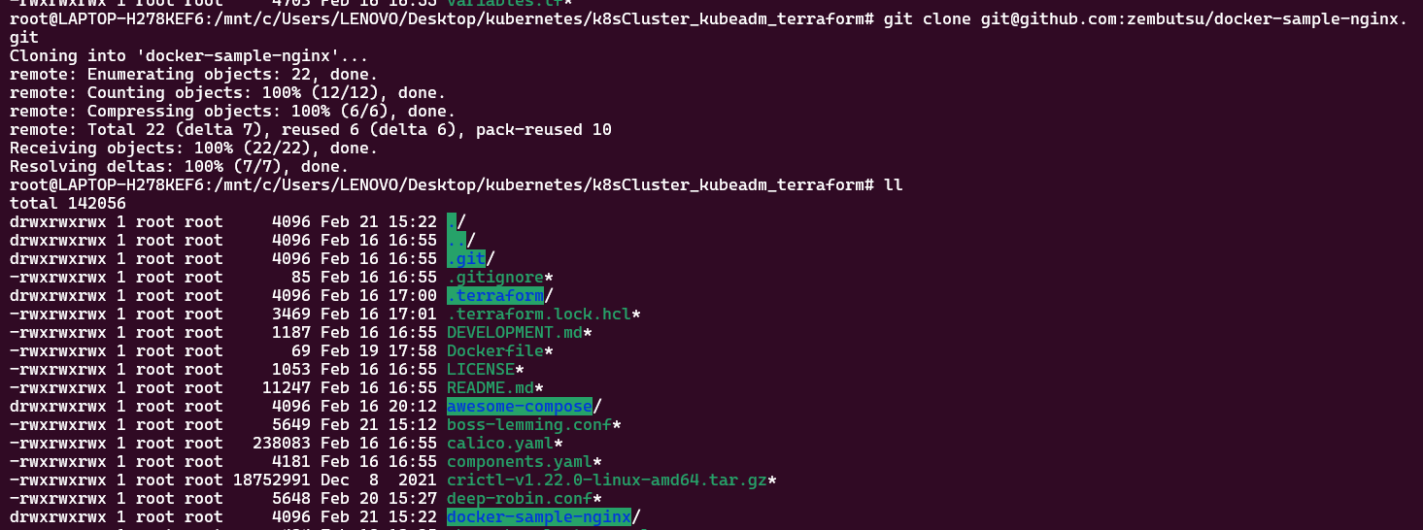

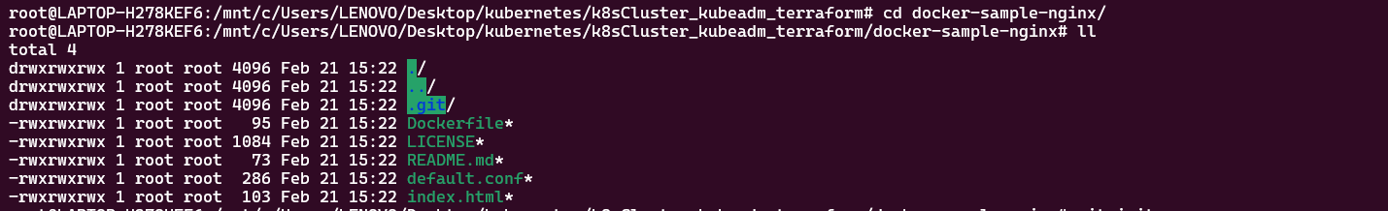

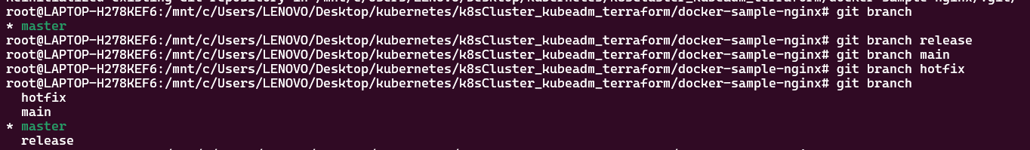

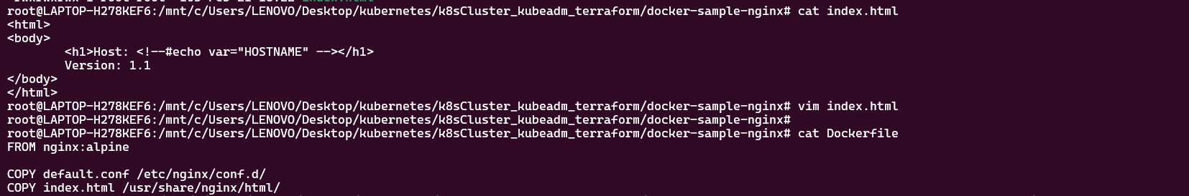

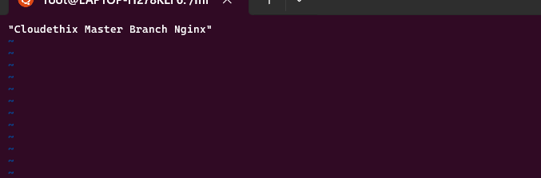

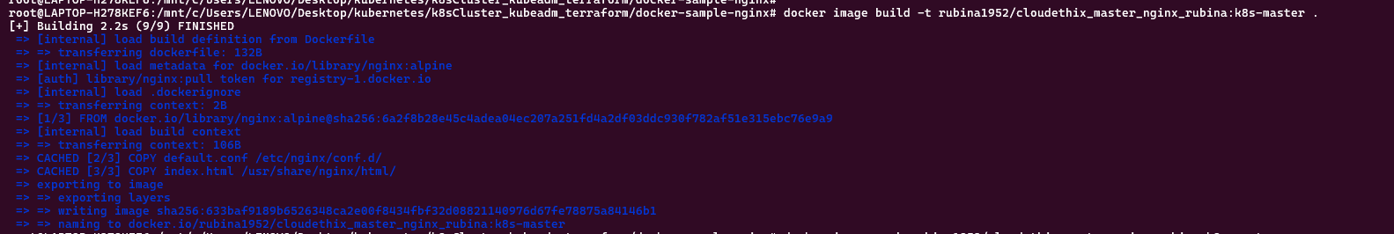

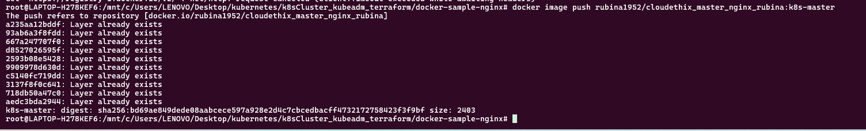

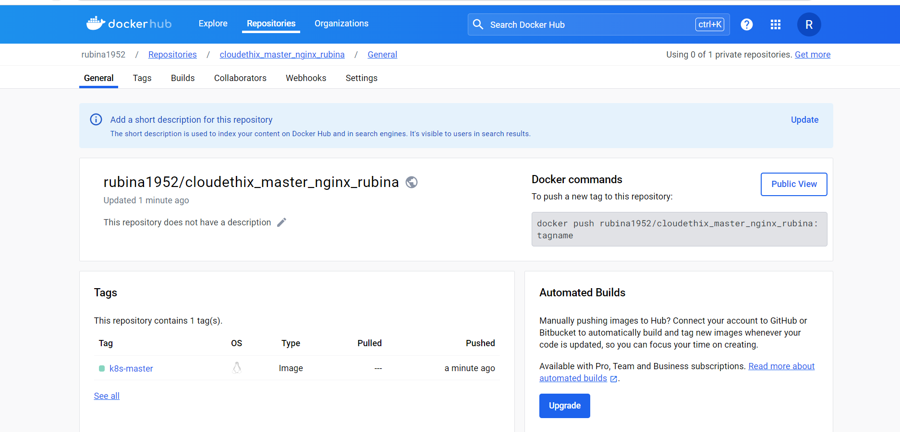

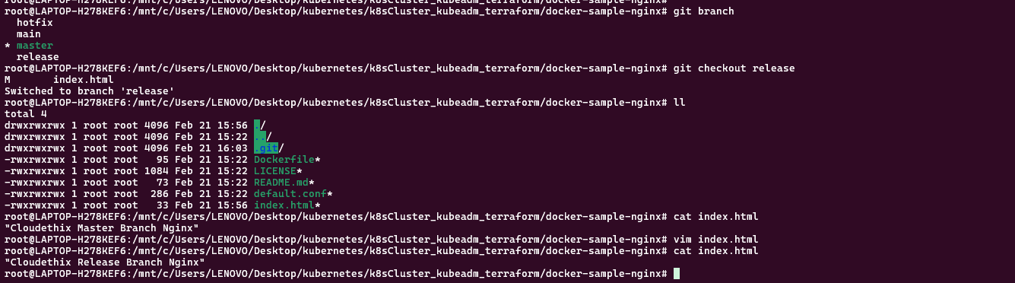

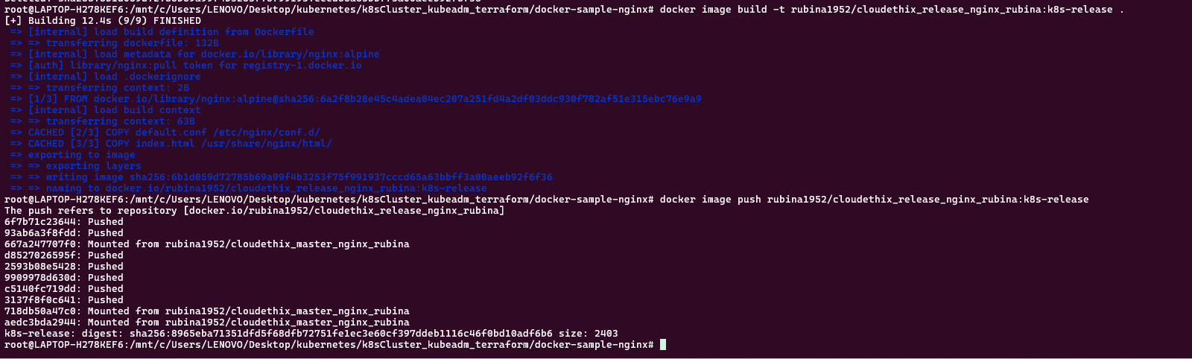

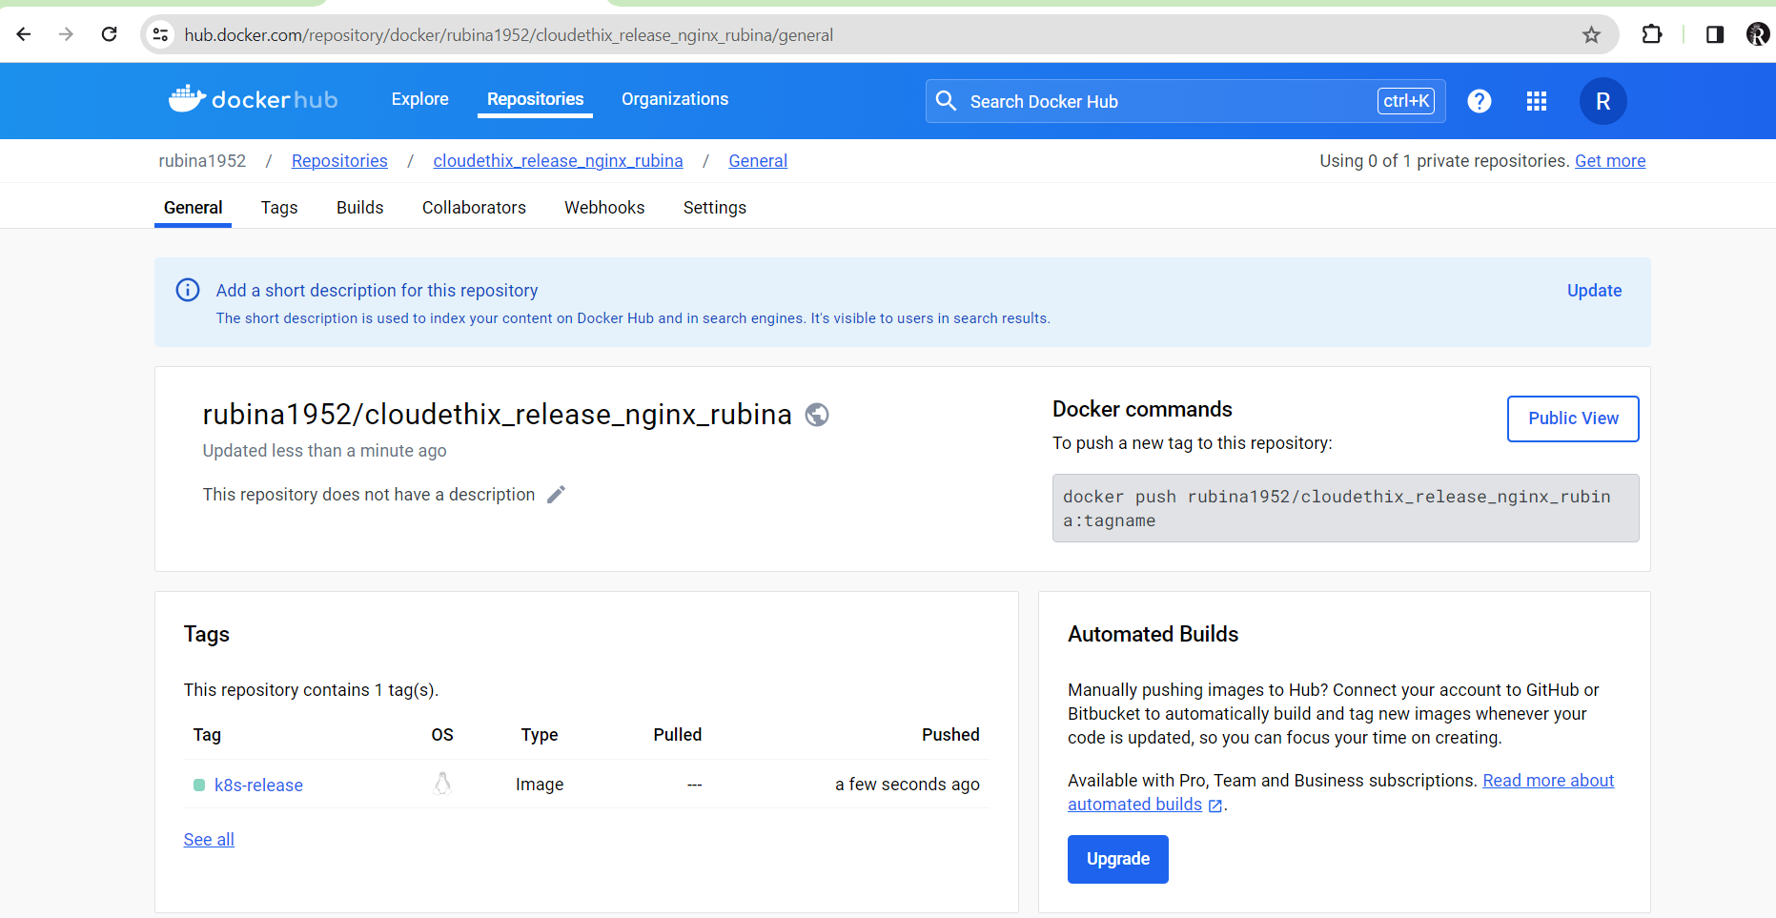

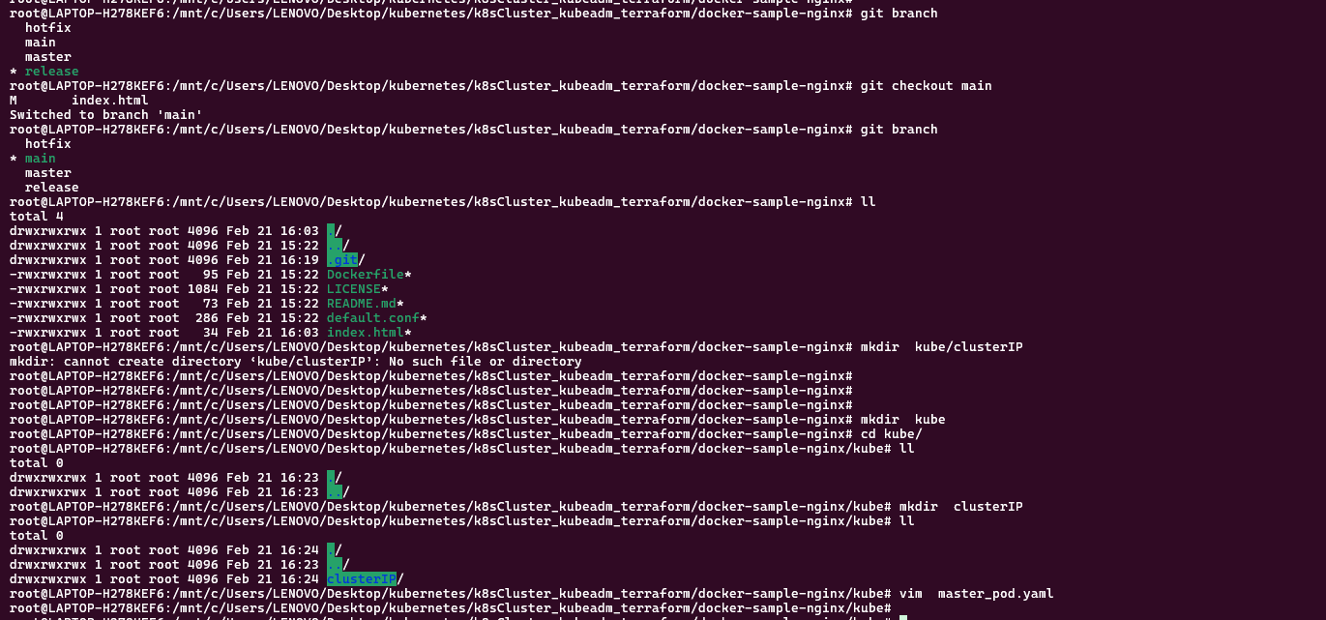

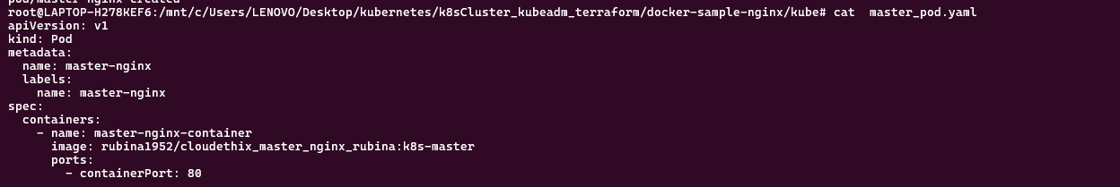

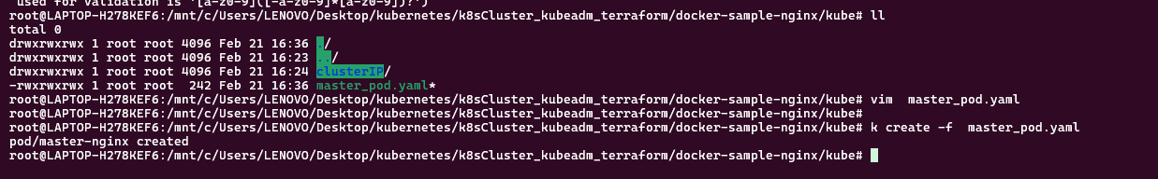

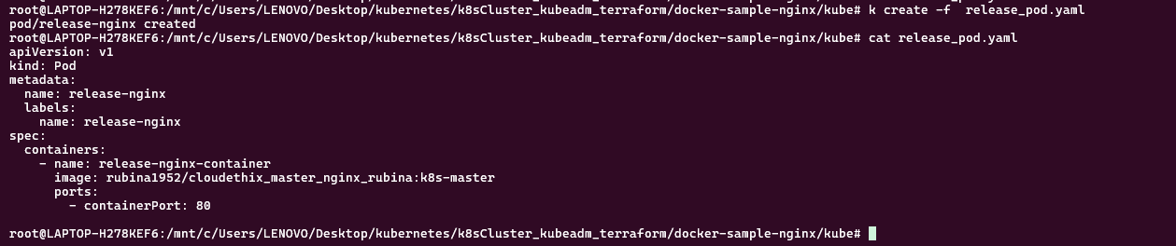

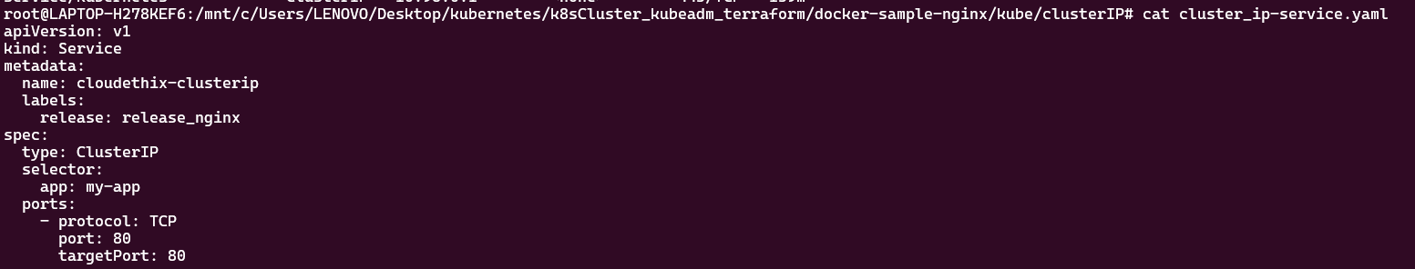

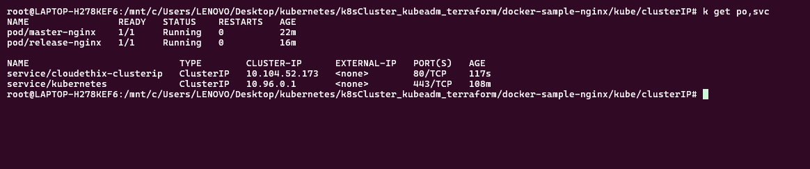





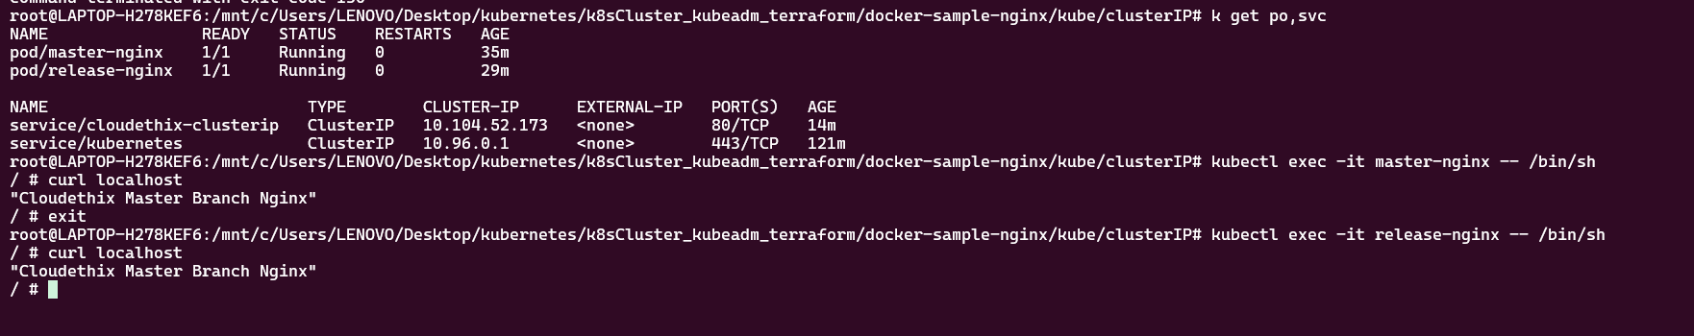



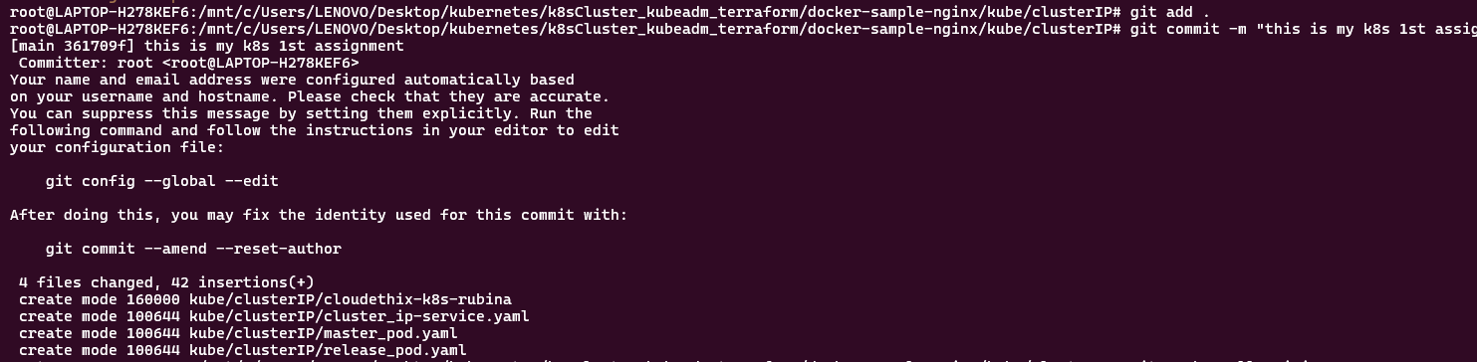

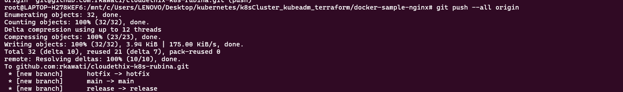

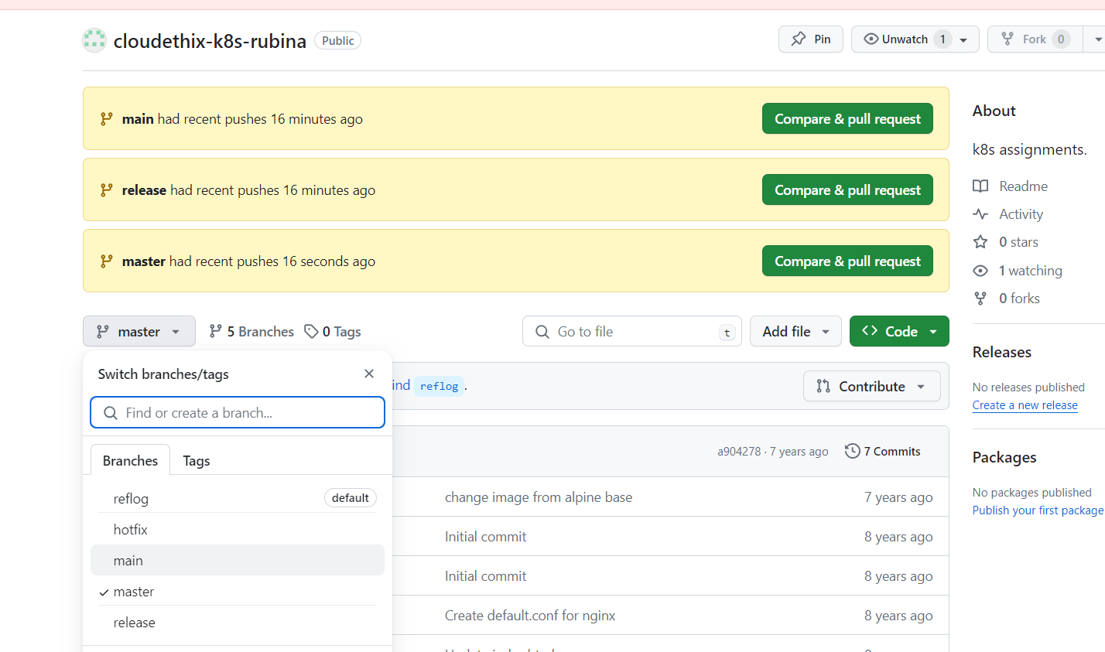

==================================================================================

Que 2 →

● In the main branch of your local repository create a directory kube/NodePort.

● Create below files from below url. Please make sure you will create NodePort service with port 30008 instead of loadbalancer. https://kubernetes.io/docs/tasks/access-application-cluster/connec ting-frontend-backend/. backend-deployment.yaml backend-service.yaml frontend-deployment.yaml frontend-NodePort-service.yaml

● Once files are created , create all the resources in your k8s cluster.

● Access all public ips with port 30008 in the browser and then check the result.

● Finally, push all the latest code to the remote repository.

● Take all screenshots and create a well formatted document

**https://kubernetes.io/docs/tasks/access-application-cluster/connecting-frontend-backend/**

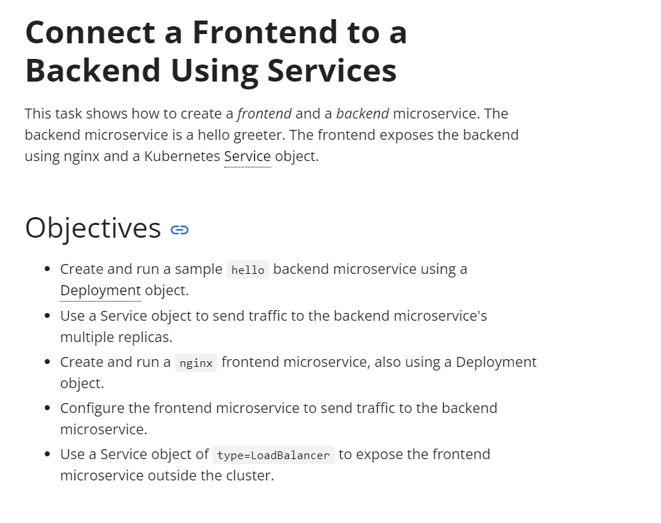

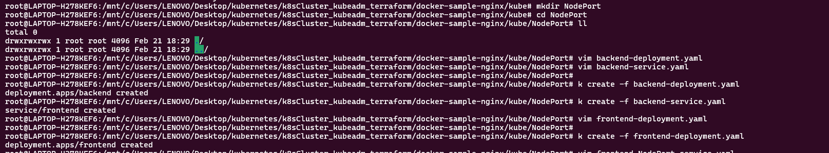

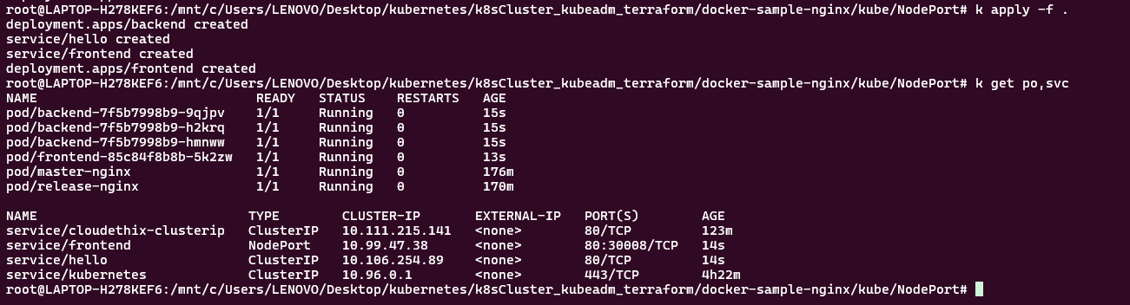

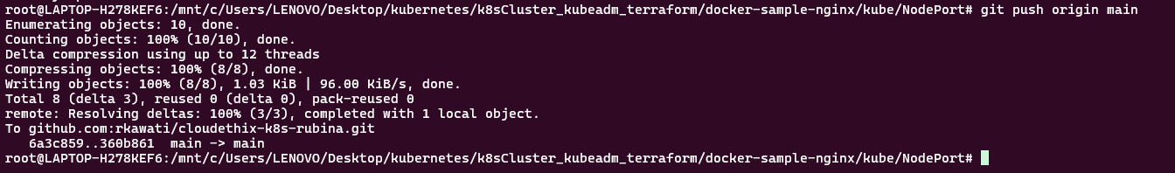

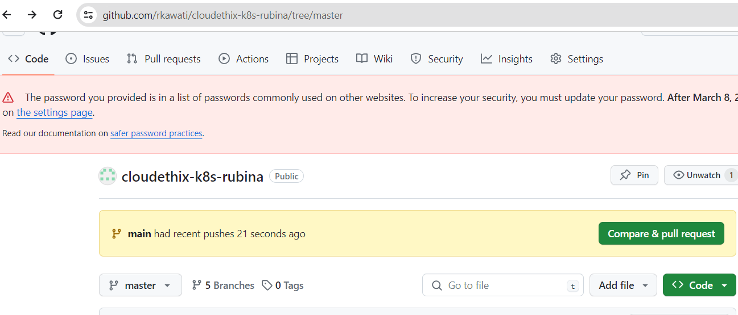

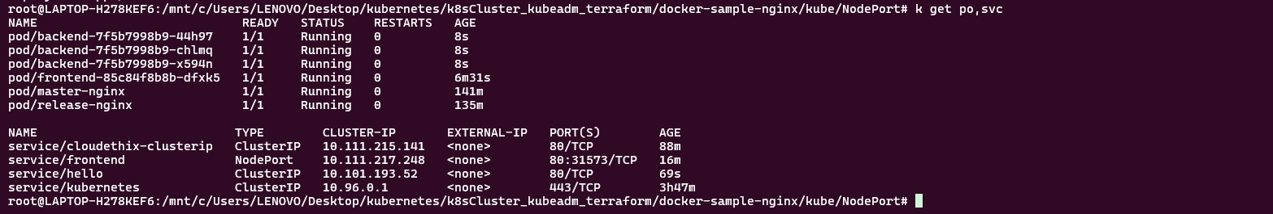

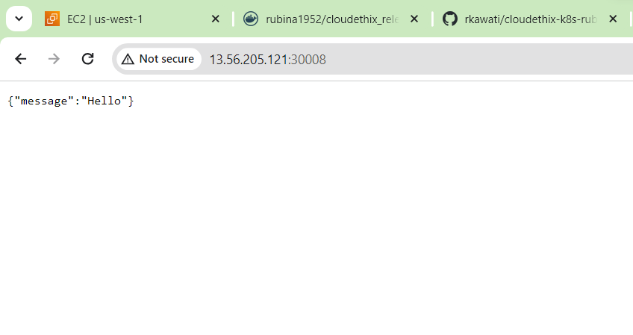

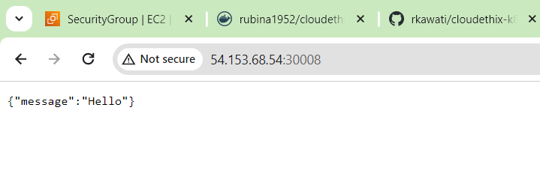

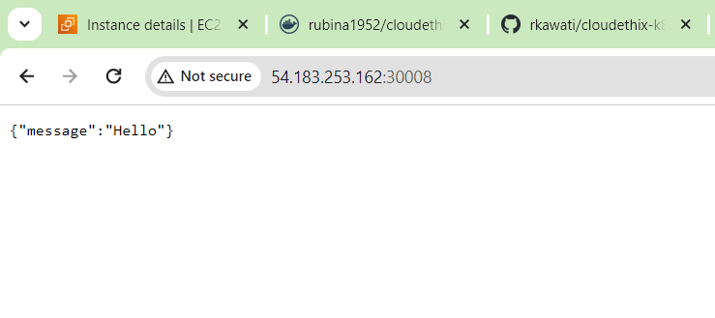

==================================================================================

Que 3 → ● Create any 2 pods and assign them to different worker nodes with nodeName property.

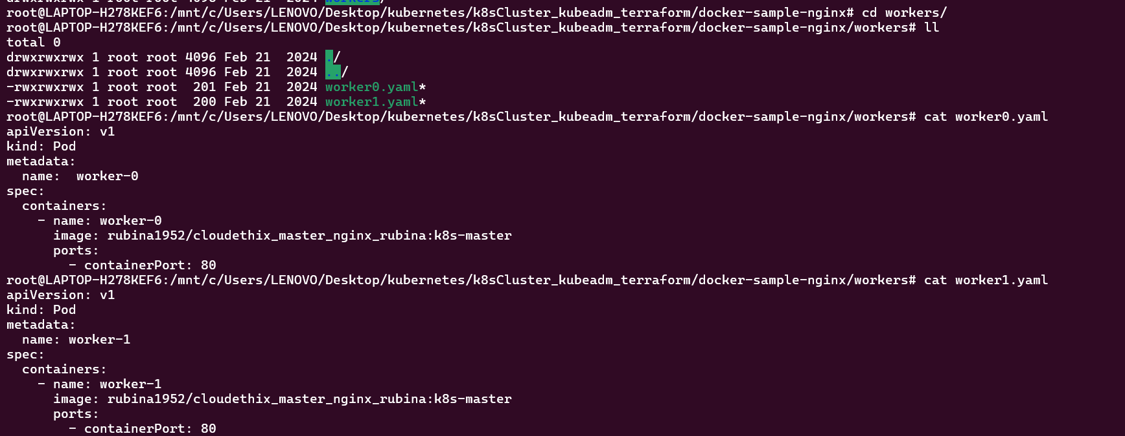

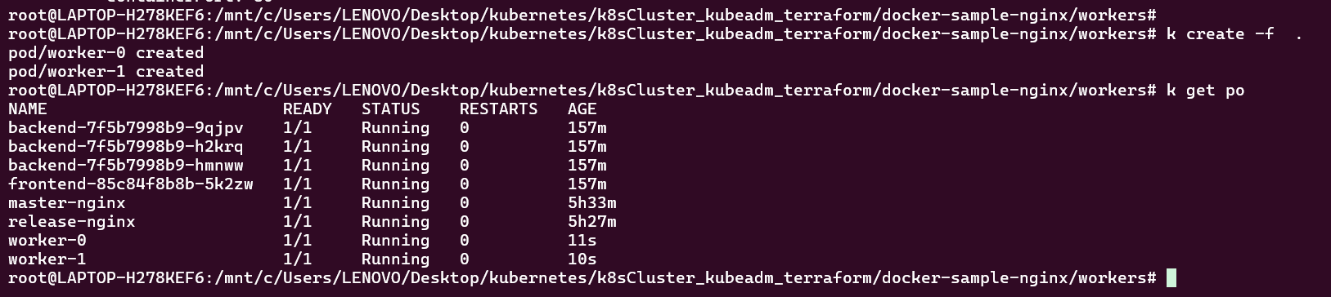

==================================================================================

Que 4 →

● Label both worker nodes such as worker-0 node as cloudethix-k8s-00 & worker-1

node as cloudethix-k8s-01.

● Once nodes are labeled, create pod00.yaml file and schedule the pod on worker-0 node with

nodeSelector property. Also create one more file named pod01.yaml & schedule the pod on

worker-1 node.

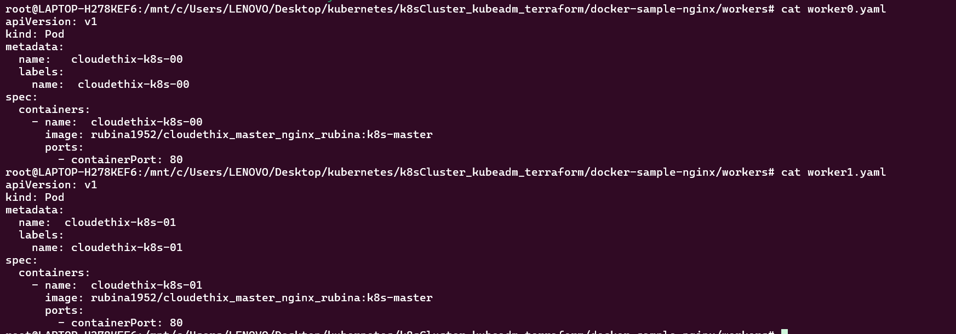

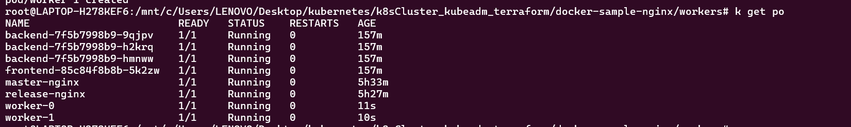

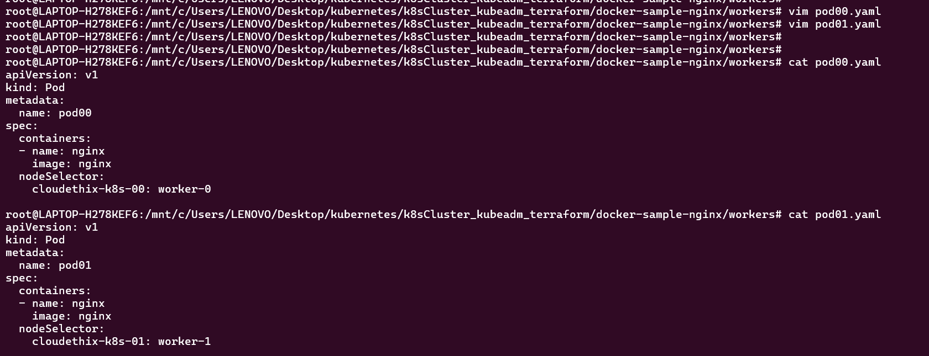



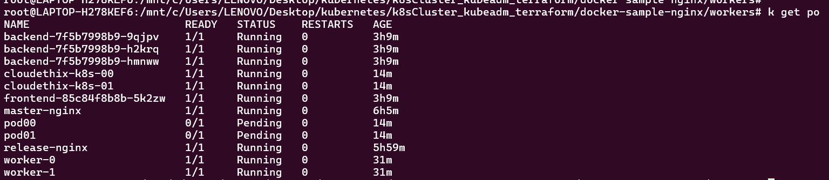

==================================================================================

Que 5 →

● Clone the below repo locally & create DaemonSet from directory DaemonSet101. <https://github.com/collabnix/kubelabs>

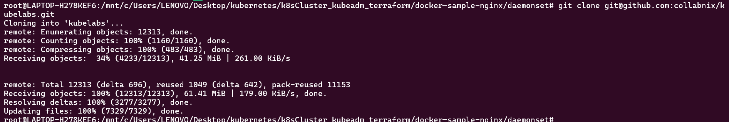

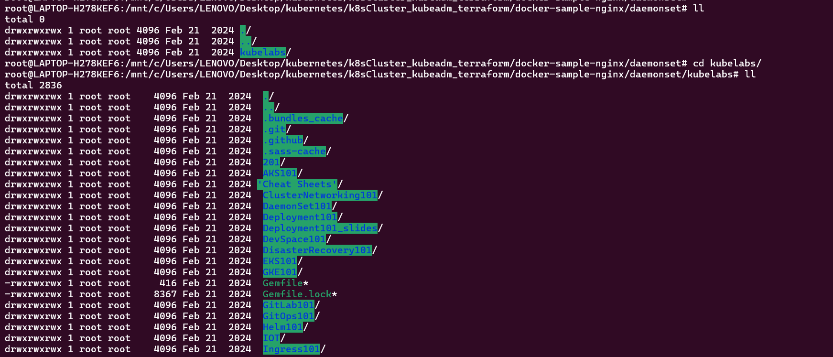

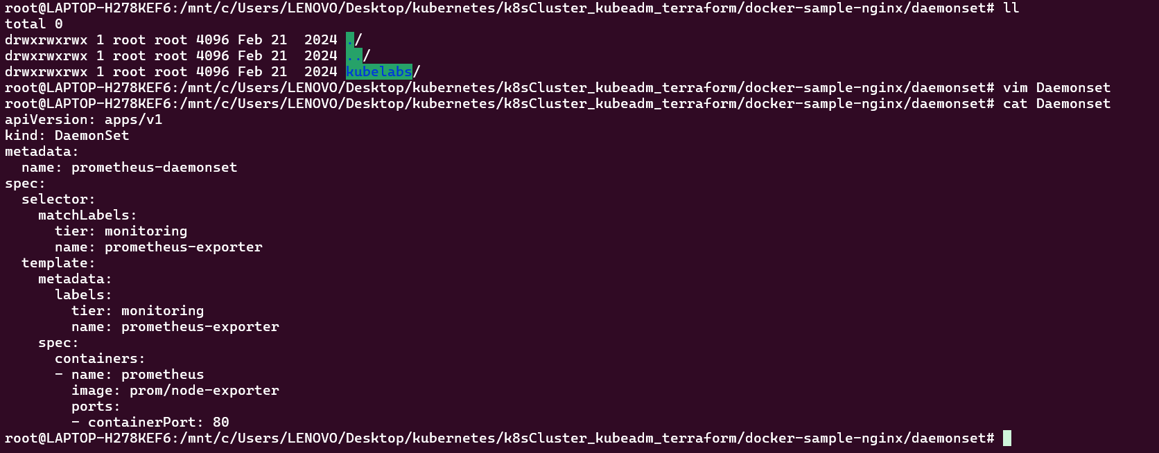

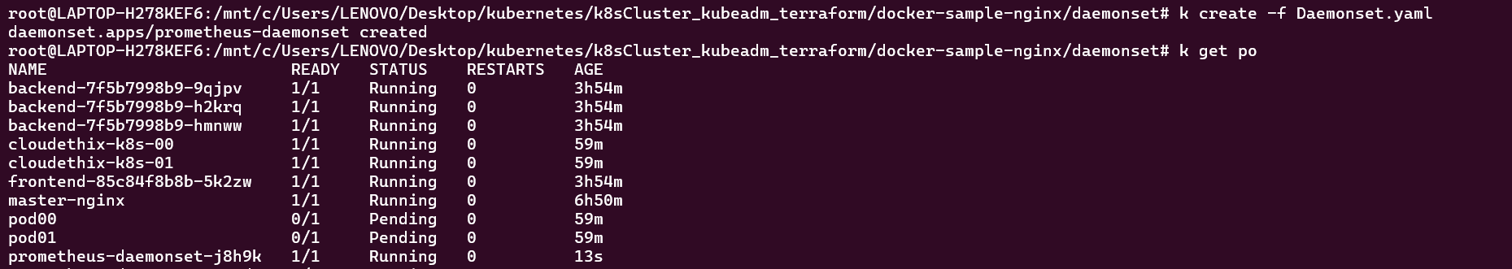

Que 6 → ● Create a static pod with name cloudethix-static in your k8s cluster. Refer below link. https://kubernetes.io/docs/tasks/configure-pod-container/static-pod

<https://kubernetes.io/docs/tasks/configure-pod-container/static-pod/>

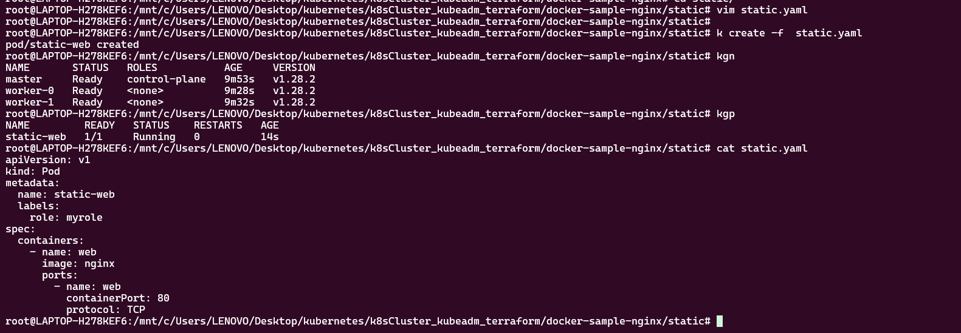

==================================================================================

Que 7 → ● Install Kubectx & kubens in your k8s cluster.

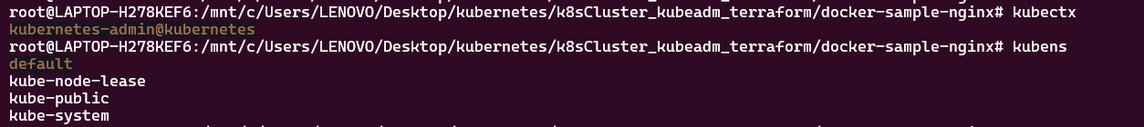

==================================================================================

Que 8 →

● Create 1 Public Docker Hub registry named flask_webapp_yourname. ● Clone below repository on your system. https://github.com/mmumshad/simple-webapp-docker.git ● Initialize a local repository & copy the code from above repo to your local repository in your working branch. ● Once code is copied to the local repository, build the docker image & add meaningful tags with version 1 and push to Docker Hub registry. ● Once Images are pushed to Docker hub registries, create a directory named kube. Inside the kube directory create deployement.yaml file with 3 replication , labels app: flask-webapp , containerPort: 8080 and add the image that you have pushed in Docker Hub registry. ● Create one service.yaml file with type nodeport & select flask-webapp with port 8080 & targetPort 8080 with any nodePort between range 30000-32768. ● Once a service is created try accessing the web page in the browser as below. (30011 is nodeport mentioned in service.yaml). Meanwhile open app.py from your code to understand paths & output. http://master_ip:30011/ http://master_ip:30011/how are you ● Now , update the app.py from your code and add below route above if __name__ == "__main__" line @app.route('/Who are you') def cloudethix(): return 'Yes, I am cloudethix, and You !!!' ● Once the file is updated , rebuild the docker image & add meaningful tags with version 2 and push to Docker Hub registry. ● Now we have the latest docker image in repo, It's time to roll out a new image. Roll out the new Image with all three ways one by one. 1. With kubectl set command 2. With kubectl edit deployment 3. With deployment.yaml file modification. ● Run the # kubectl rollout command to check status and history. ● Note:- Once above step 1 is done , run # kubectl rollout undo deployment command to rollback the change and then try a second way of rollout. ● In the browser run all three routes & notice the changes. http://master_ip:30011/ http://master_ip:30011/how are you http://master_ip:30011/Who are you ● Once done with all above steps , commit all the changes to the remote repository. ● Capture the snap and prepare a well formatted document. 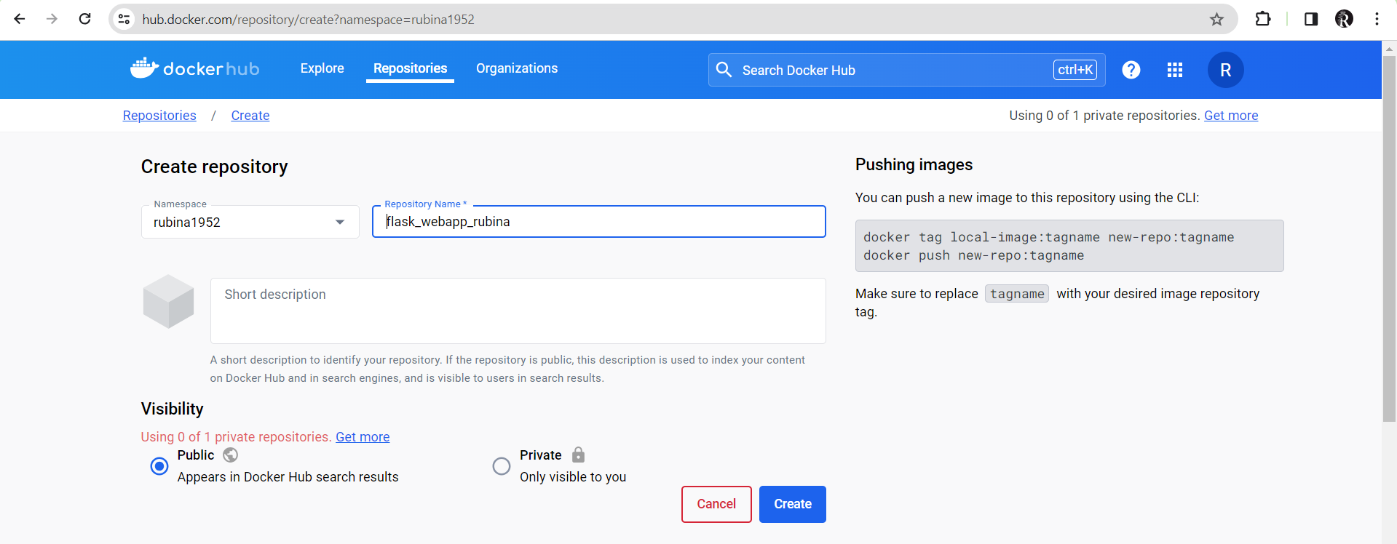

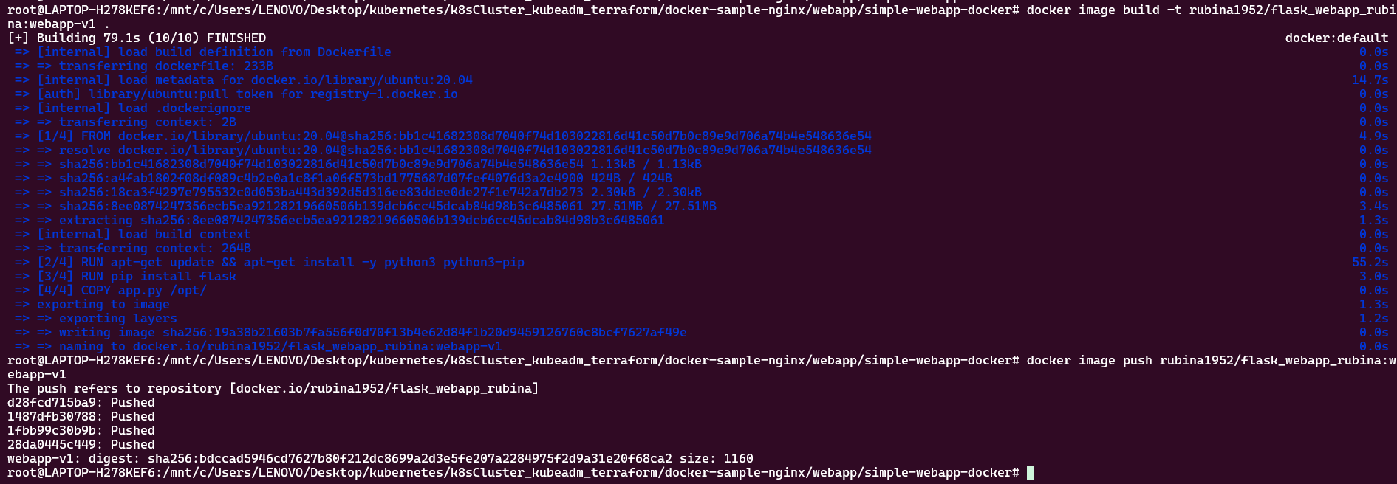

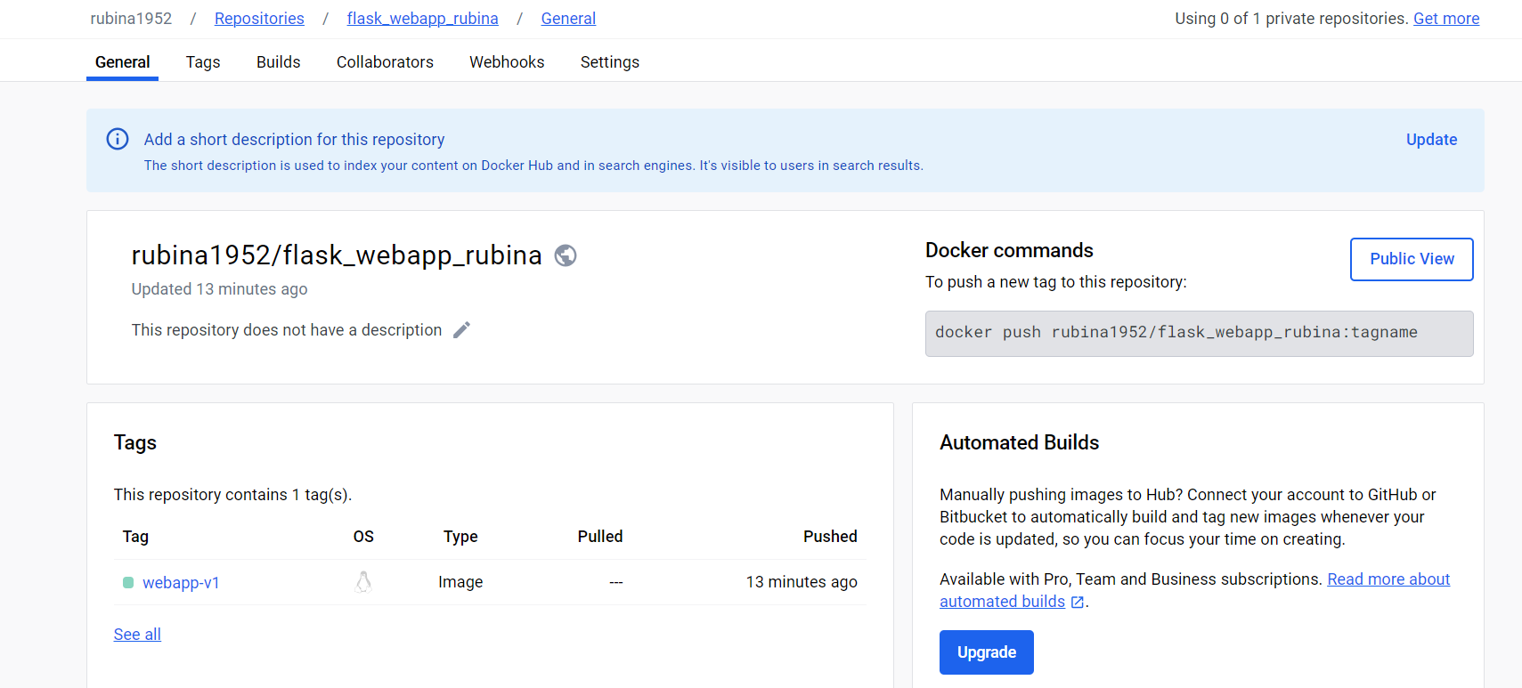

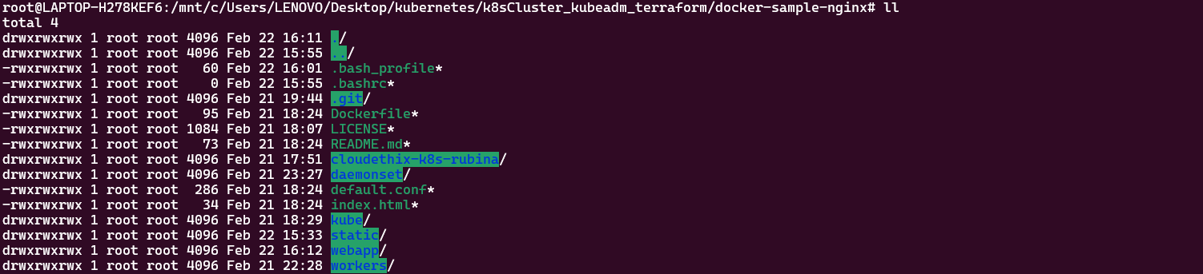



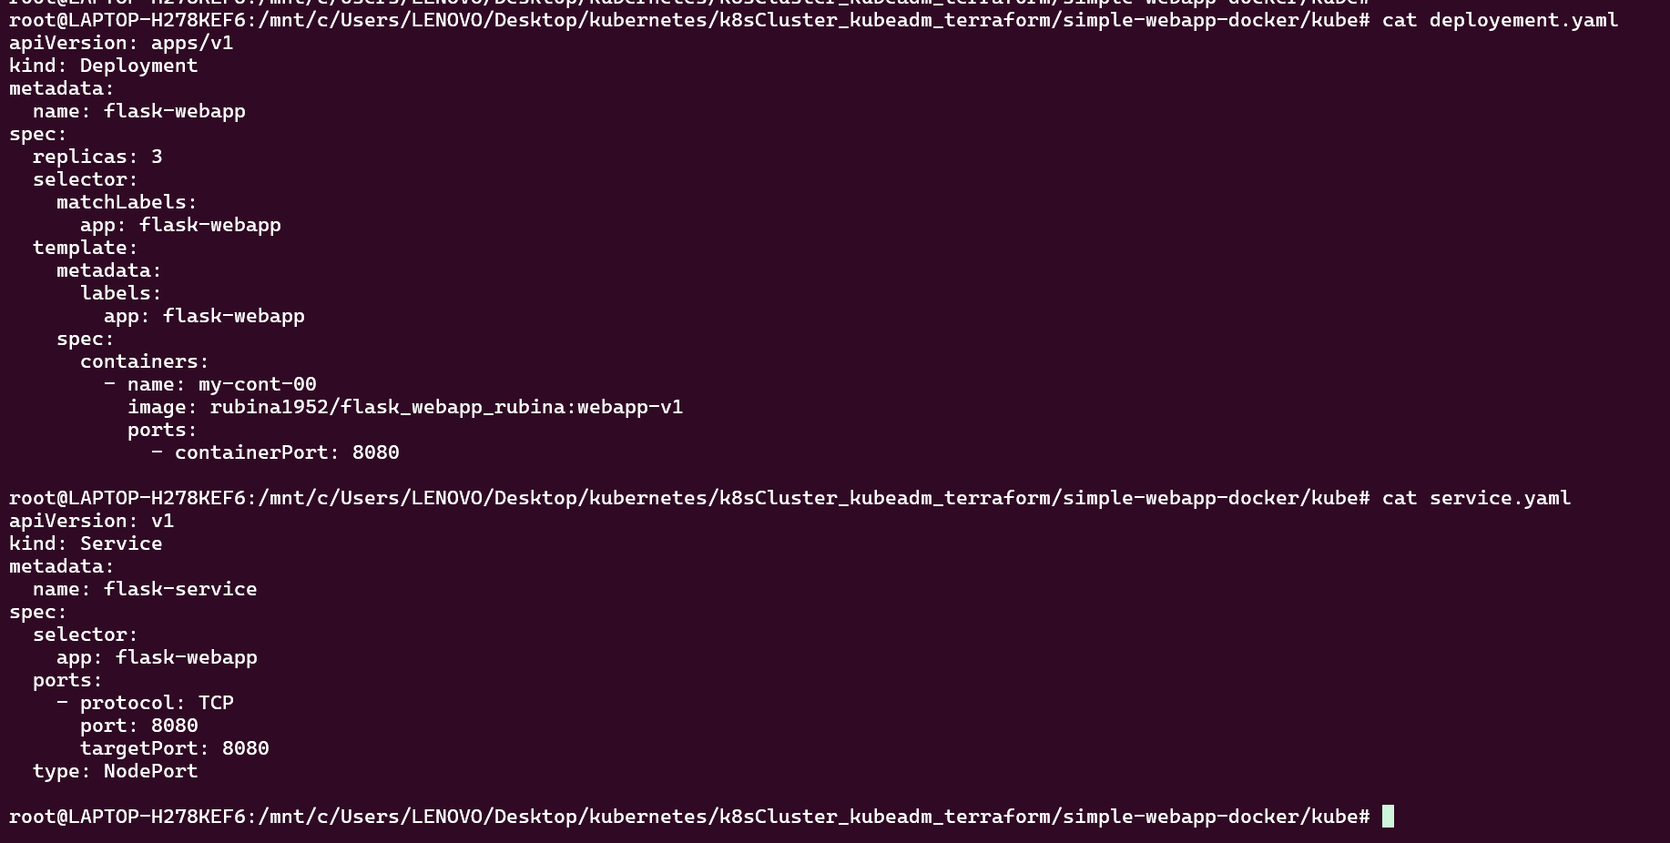

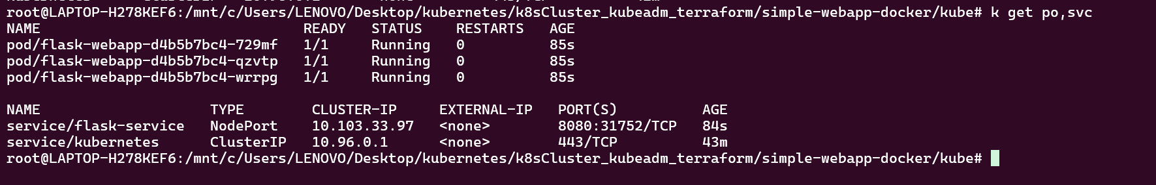

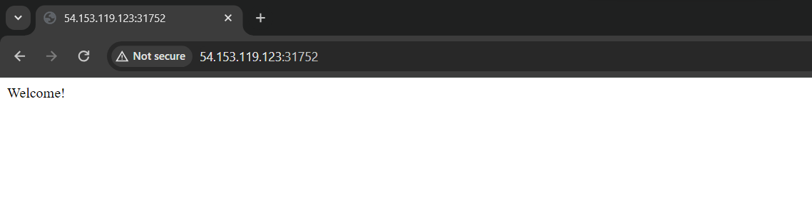

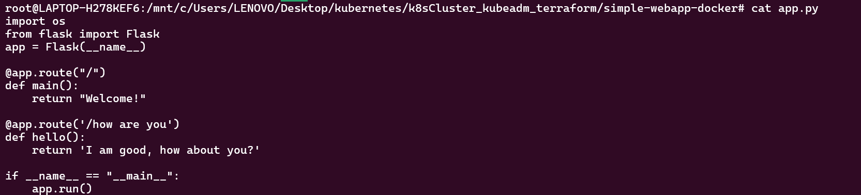

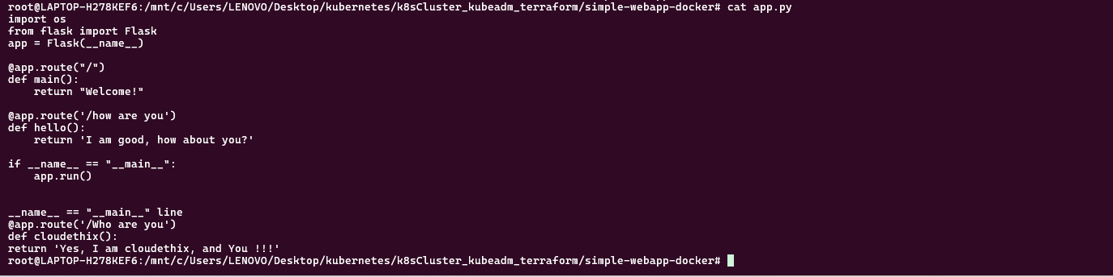



===============================================================================================

Que 10 → ● Create 1 Public Docker Hub registry named cloudethix_configmap_yourname. ● Clone below repository on your system. https://github.com/zembutsu/docker-sample-nginx.git ● Initialize a local repository & copy the code from above repo to your local repository in the working branch. ● Once code is copied , build a docker image from docker file and add meaningful tags and push to docker hub repository. ● Once Images are pushed to Docker hub registries, create a directory named kube. Inside the kube directory create deployement.yaml file with 3replication , labels app: frontend-webapp , containerPort: 80 and add the image that you have pushed in Docker Hub registry. ● Create one service.yaml file with type nodeport & select frontend-webapp pod with port 80 & targetPort 80 with any nodePort between range 30000-32768. ● Once the service is created try accessing the web page in the browser as below. Notice the changes & take the snap. ● Now create a configmap.yaml file with below data & delete the deployment that you have created.

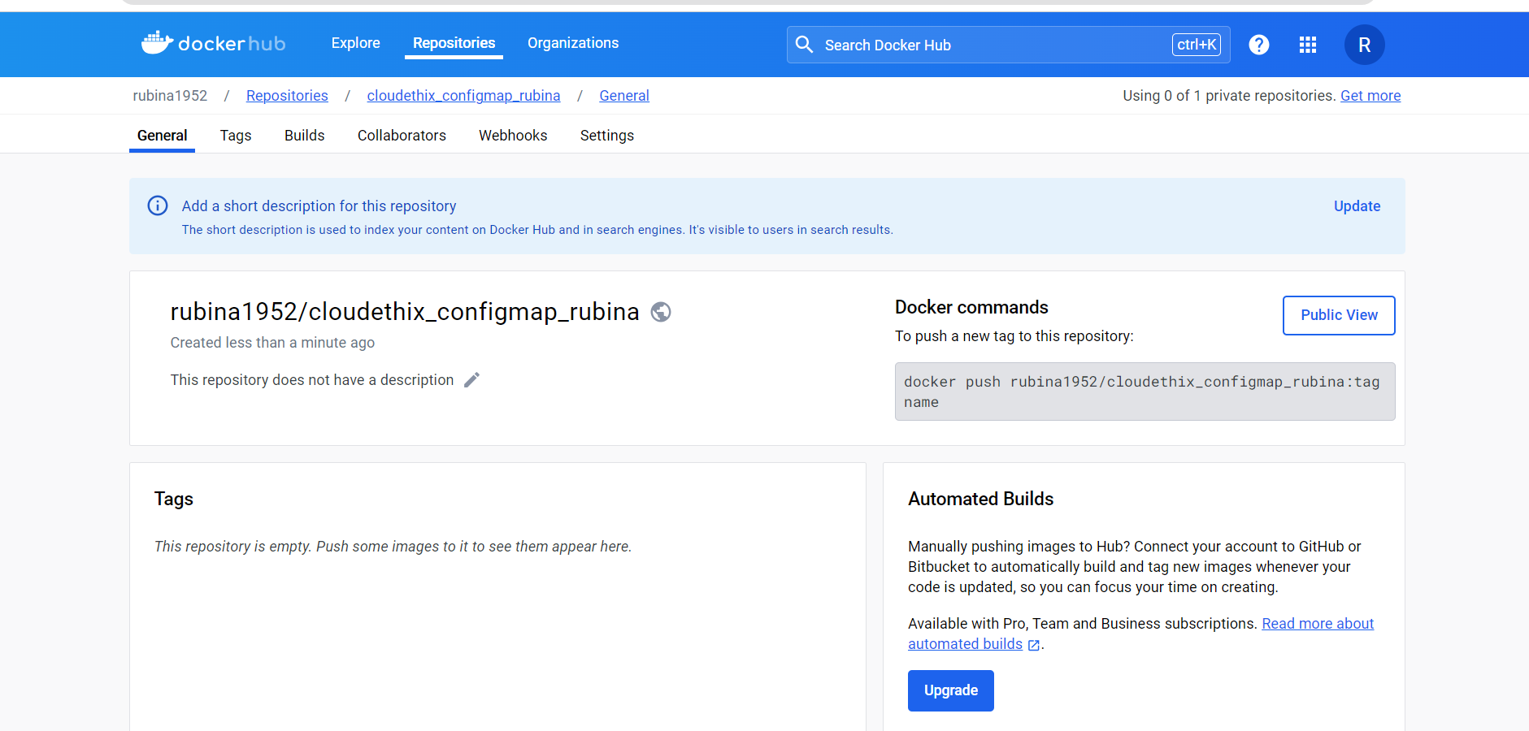

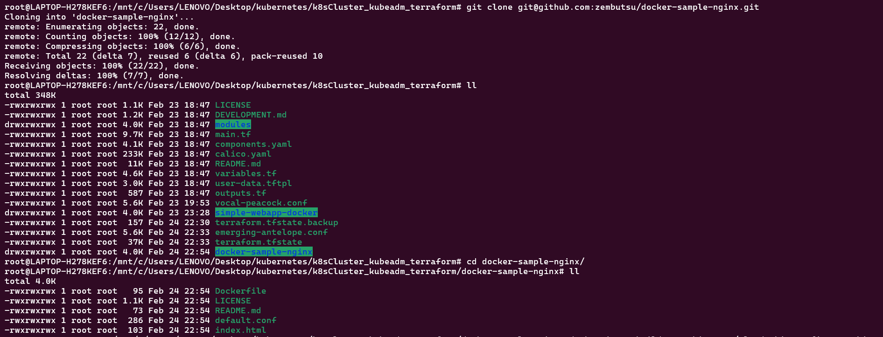

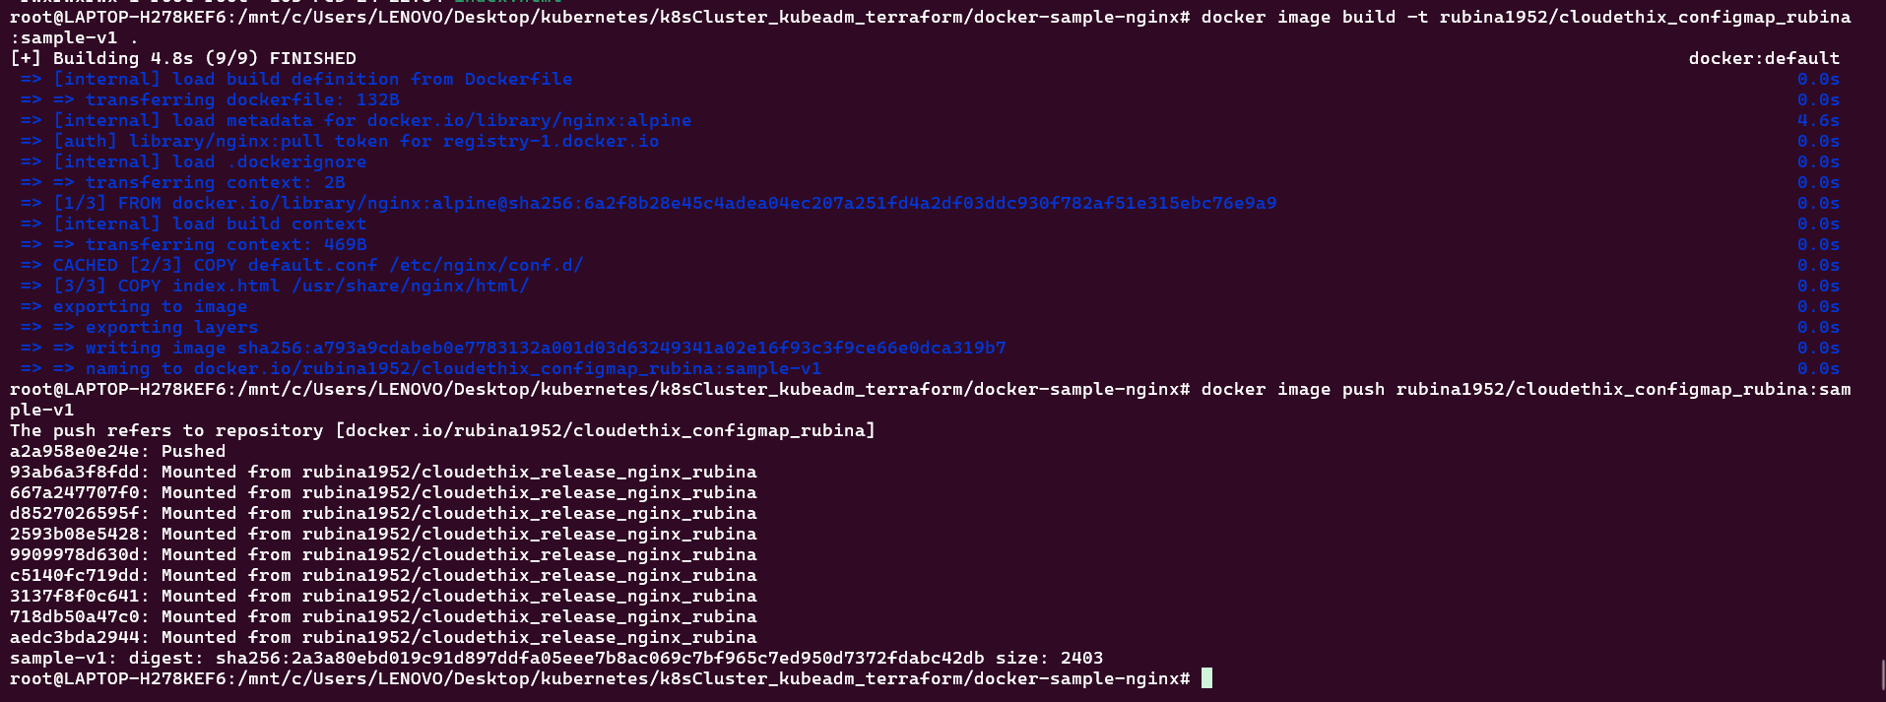

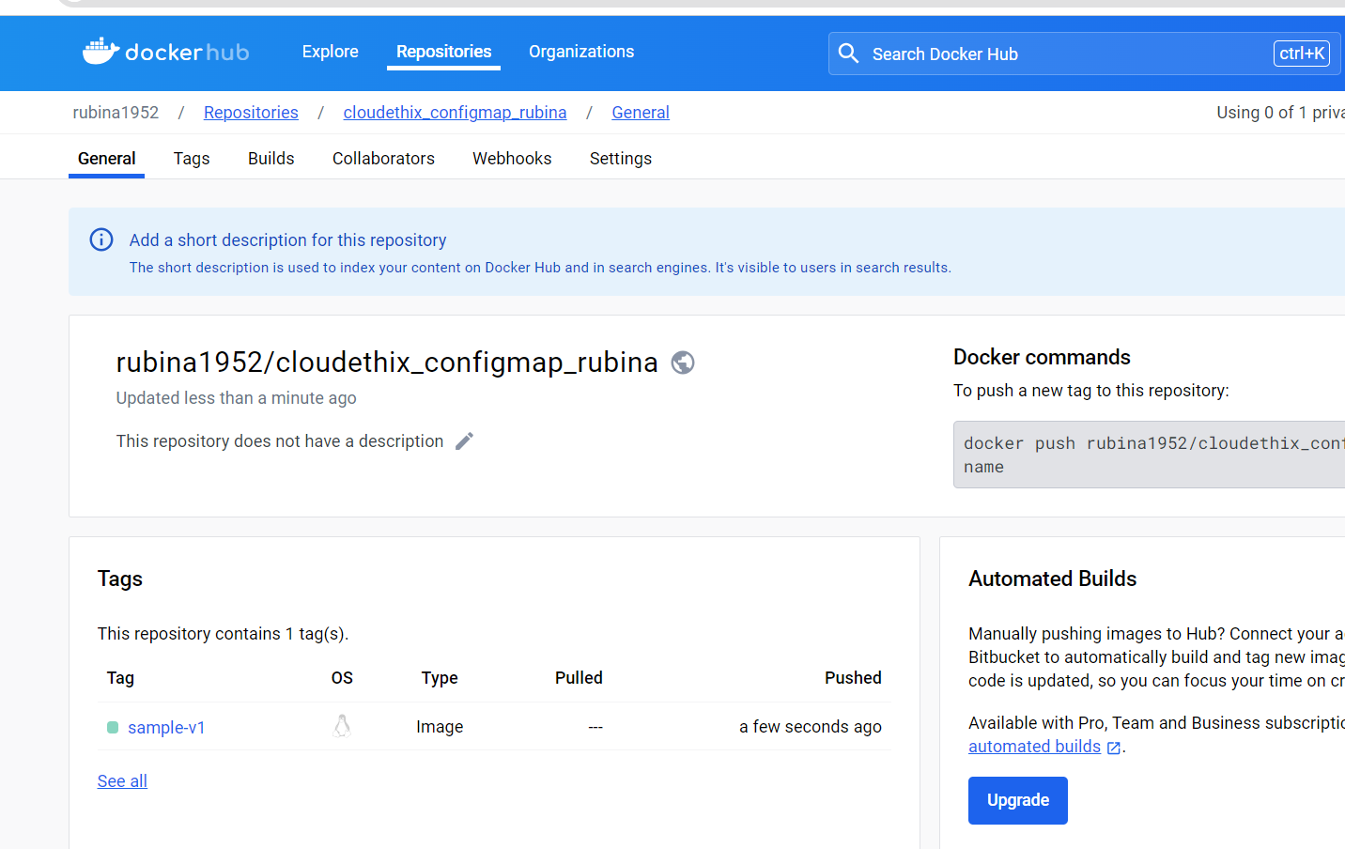

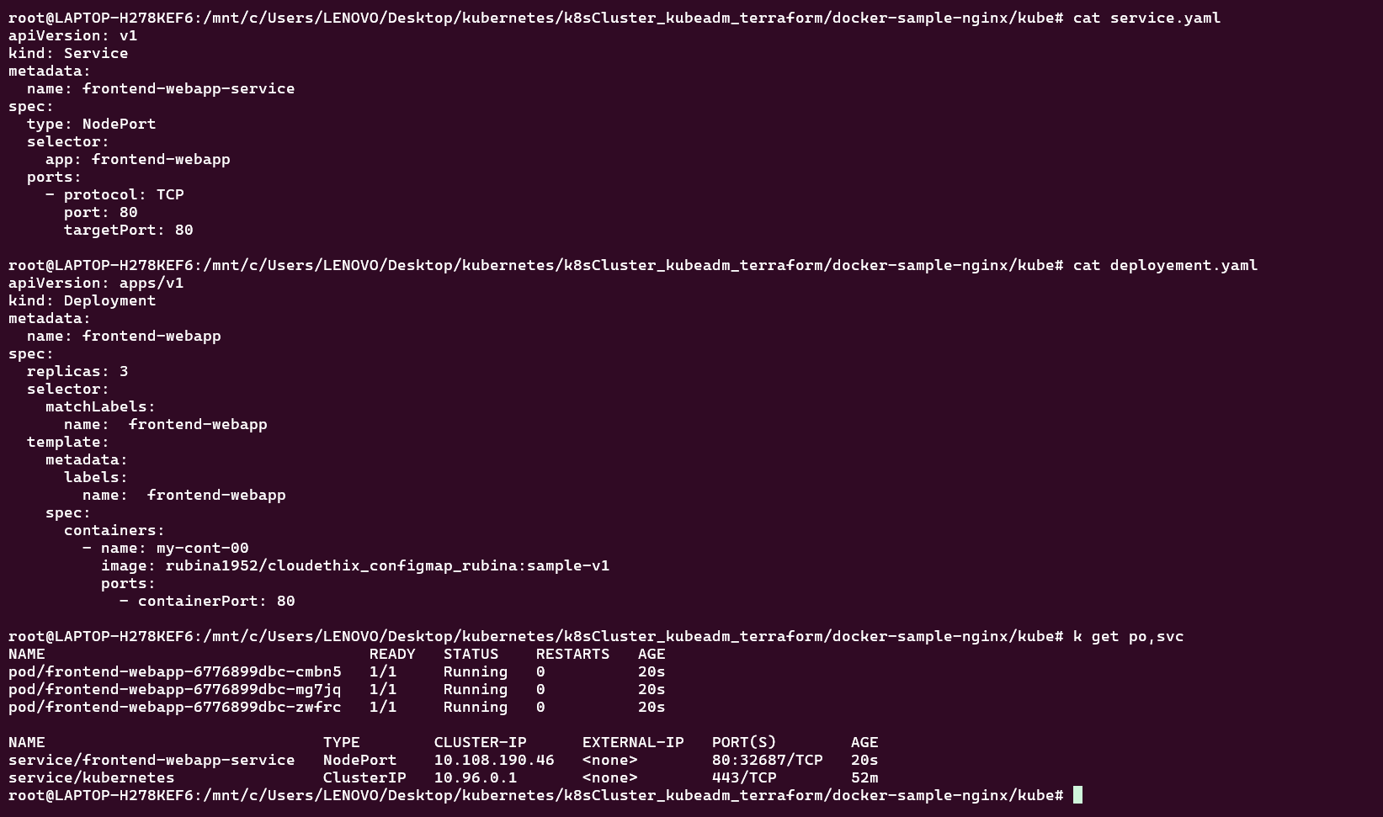

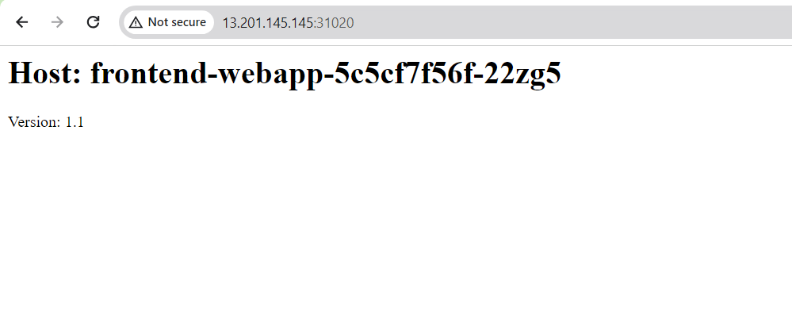

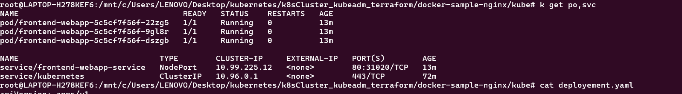



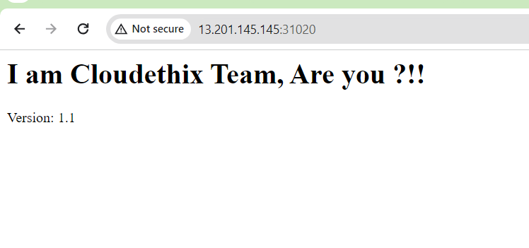

Que 11 →

● Create 1 Public Docker Hub registry named cloudethix_multicontainer_yourname. ● Clone below repository on your system. https://github.com/janakiramm/Kubernetes-multi-container-pod.git ● Initialize a local repository & copy the code from above repo to your local repository in any of your working branches. ● Once code is copied , go to the Build directory and build docker image from docker file and add meaningful tags and push to docker hub repository. ● Now go to the deploy directory and notice the files. ● Here, web-pod-1.yml file will create the pod with two containers (Multi container). Take a note of lables , name of containers and ports. Also, please make sure you will update the python container image that you have pushed to your docker registry. ● Now, open web-svc.yml file and notice service Type , selectors & targetPort. Apply the file. ● Now open db-pod.yml & notice the lables , name , Image, containerPort and apply the file. ● Now open the db-svc.yml file and notice service Type , selectors & targetPort. Apply the file. ● Once above files are applied , Check that the Pods and Services are created using command line or lens. ● Now , from the command line run below urls & notice the changes. # curl http://$NODE_IP:$NODE_PORT/init Initialize the database with sample schema ● Now it's time to Insert some sample data. Make sure you will use correct $NODE_IP:$NODE_PORT # curl -i -H "Content-Type: application/json" -X POST -d '{"uid": "1", "user":"John Doe"}' <http://$NODE_IP:$NODE_PORT/users/add>

# curl -i -H "Content-Type: application/json" -X POST -d '{"uid": "2", "user":"Jane Doe"}' http://$NODE_IP:$NODE_PORT/users/add # curl -i -H "Content-Type: application/json" -X POST -d '{"uid": "3", "user":"Bill Colls"}' http://$NODE_IP:$NODE_PORT/users/add # curl -i -H "Content-Type: application/json" -X POST -d '{"uid": "4", "user":"Mike Taylor"}' http://$NODE_IP:$NODE_PORT/users/add ● Now access the data that we have added to database using below command. # curl http://$NODE_IP:$NODE_PORT/users/1 ● The second time you access the data, it appends '(c)' indicating that it is pulled from the Redis cache. ● Also, try to access mysql shell i.e db pod & run select * from the users table. check app.py for DB related information. ● Prepare proper documentation in brief & write start to end flow. Refer below link if you face any issues. <https://github.com/janakiramm/Kubernetes-multi-container-pod>

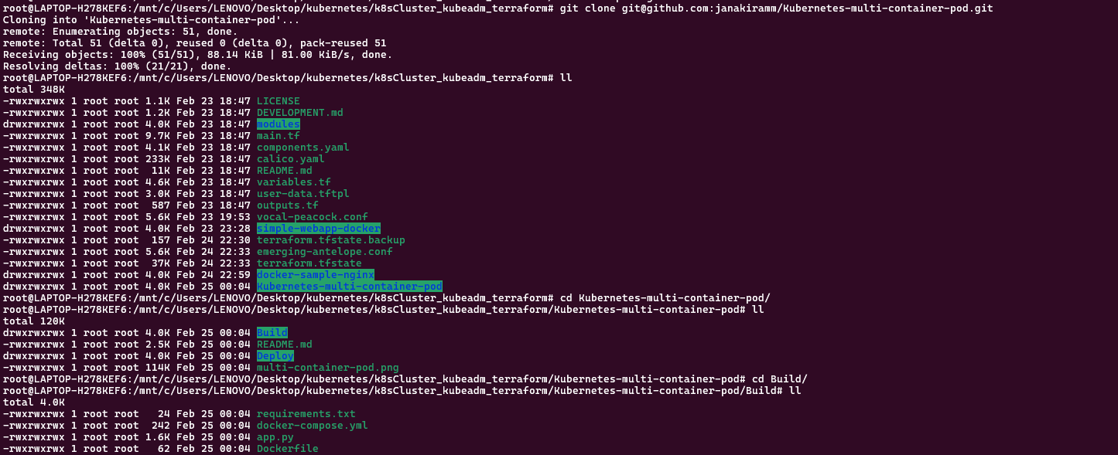

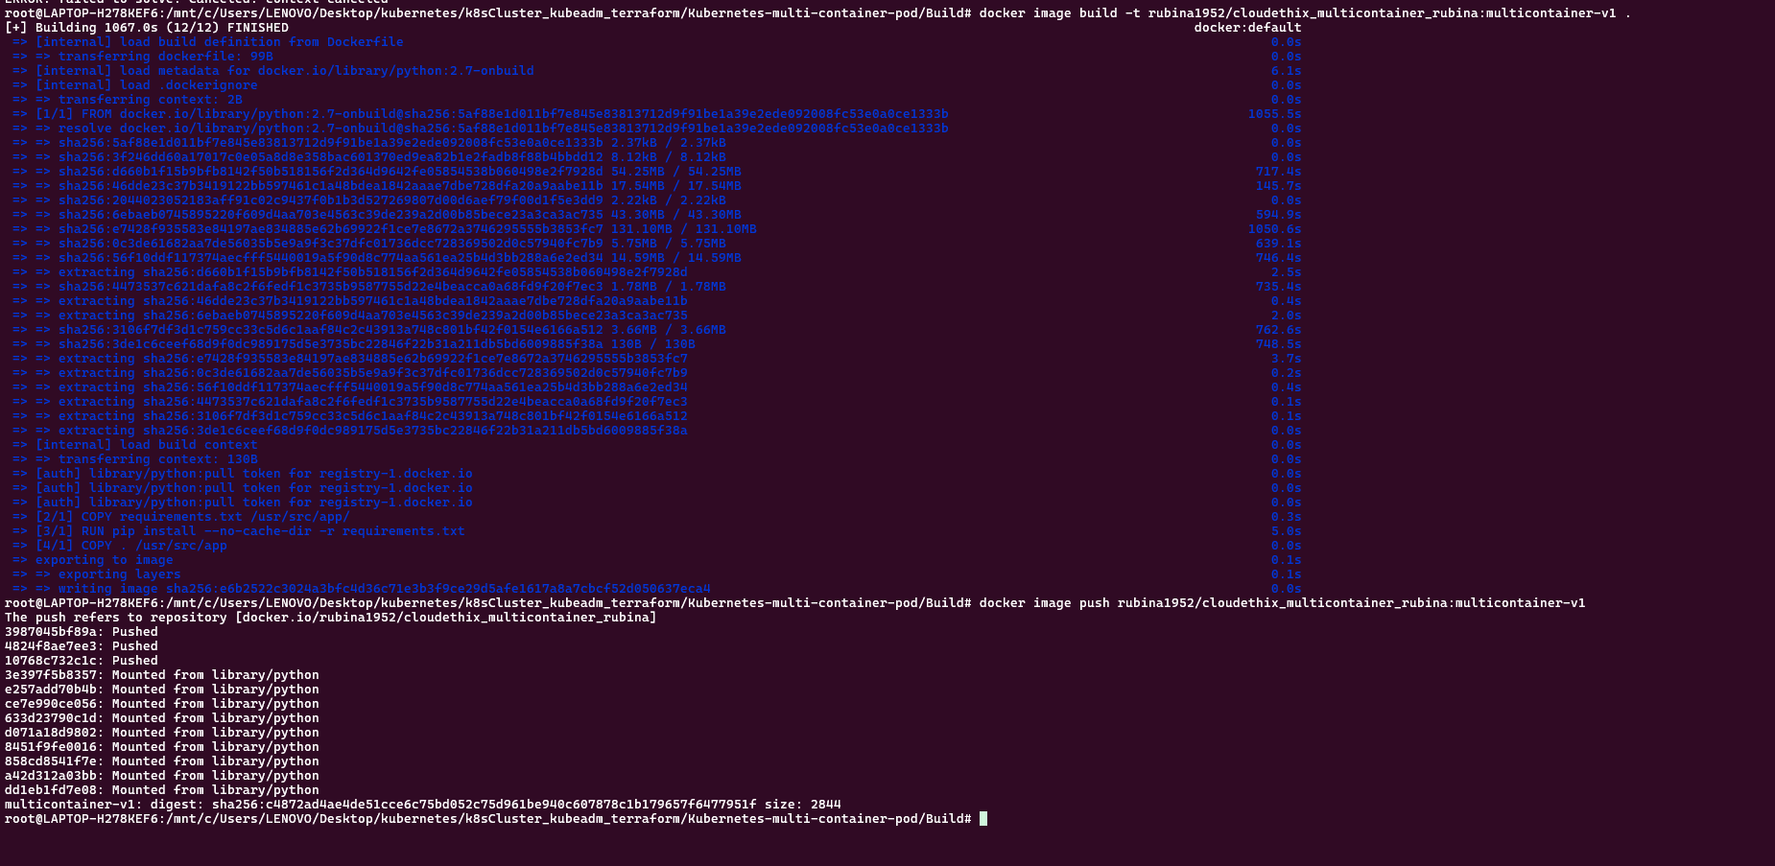

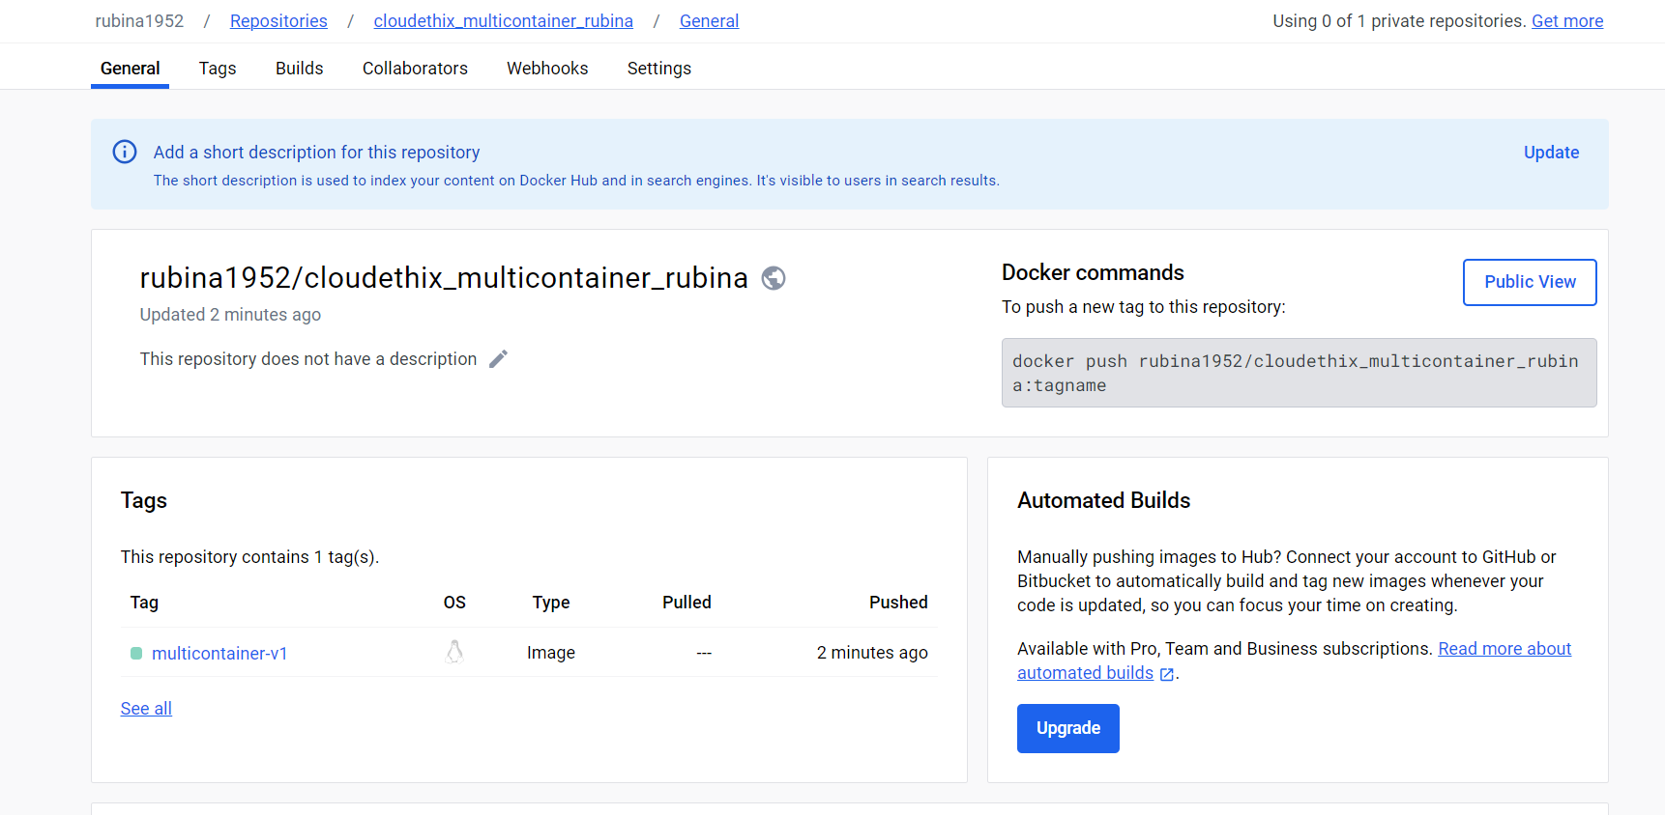

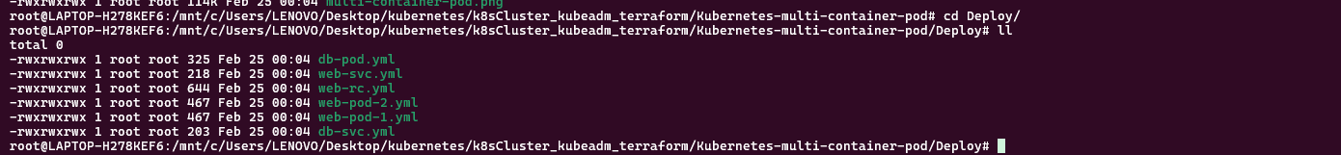

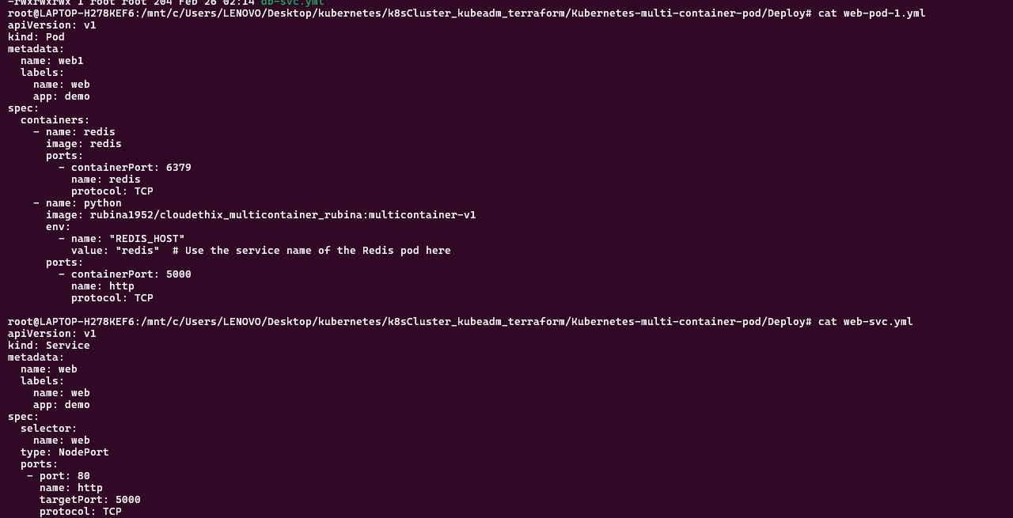

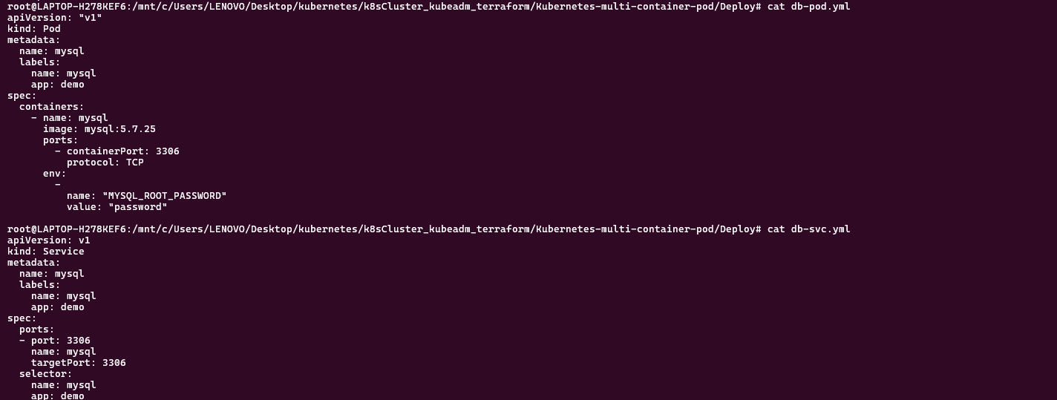

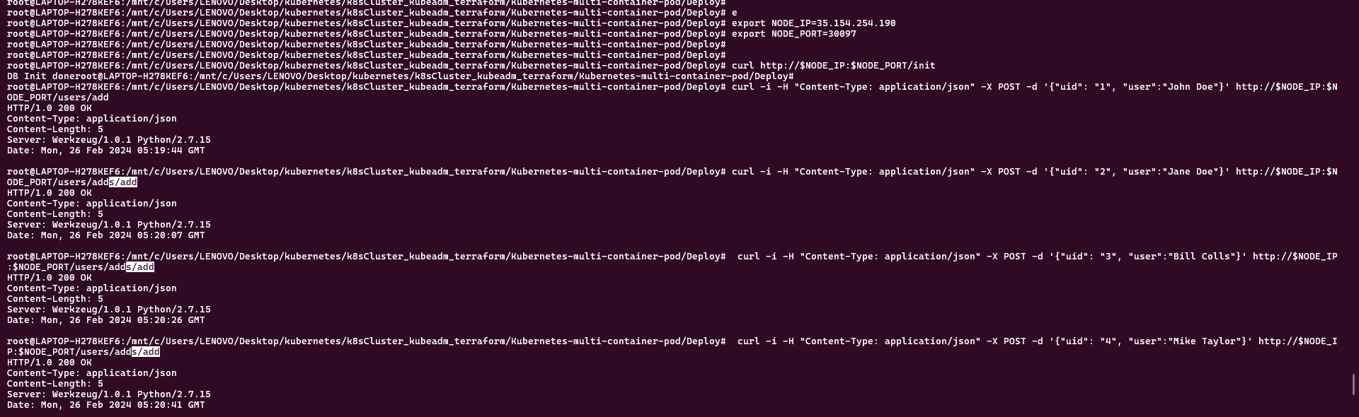



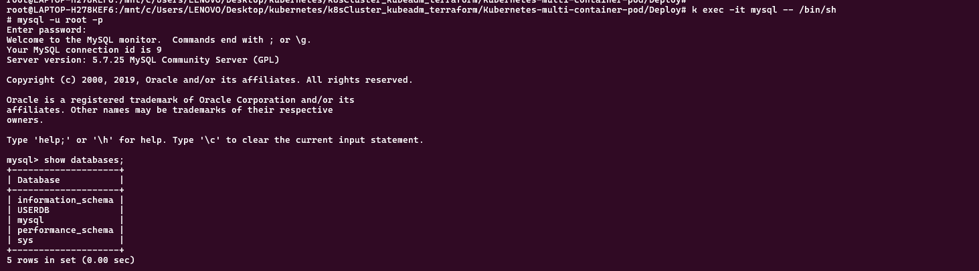

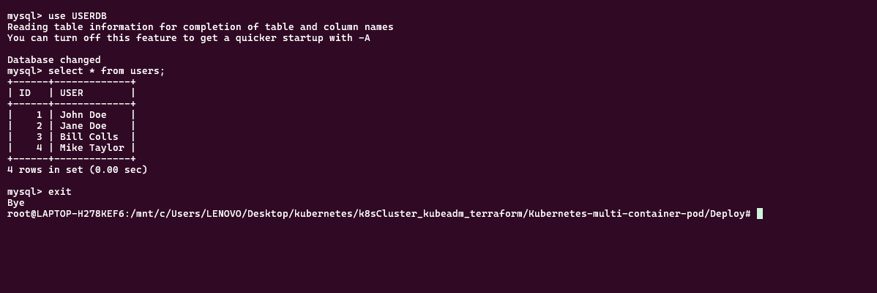

Que 12 → ● Create 1 Public Docker Hub registry named cloudethix_Initcontainer_yourname. ● Clone below repository on your system. https://github.com/janakiramm/simpleapp.git ● Initialize a local repository & copy the code from above repo to your local repository in any of your working branch. ● Once code is copied , go to the Build directory and build docker image from docker file and add meaningful tags and push to docker hub repository. ● Once Images are pushed to Docker hub registries, create a directory named kube. Inside the kube directory create deployement.yaml file with 3 replication , label app: simpleapp-webapp , containerPort: 80 and add the image that you have pushed in Docker Hub registry. ● Create one service.yaml file with type nodeport & select simpleapp-webapp pod with port 80 & targetPort 80 with any nodePort between range 30000-32768. ● Open the webpage in the browser and notice the changes and capture the snap. ● Then delete the deployment that you have just created. ● Update the deployment.yaml file and add volumeMounts with mountPath /usr/share/nginx/html from emptyDir: {} volume. ● Once above changes are added, add initContainers block with below parameters. Also add volumeMounts for Init Container with mountPath "/work-dir" from emptyDir: {} volume. initContainers: - name: install image: busybox:1.28 command: - wget - "-O" - "/work-dir/index.html" - http://info.cern.ch volumeMounts: - name: workdir mountPath: "/work-dir" ● Add volumes with emptyDir: {} in deployment.yaml file. ● Once the deployment.yaml file is ready, create the deployment & access the page in the browser and notice the changes. ● Prepare a well formatted document and write your understanding step by step.

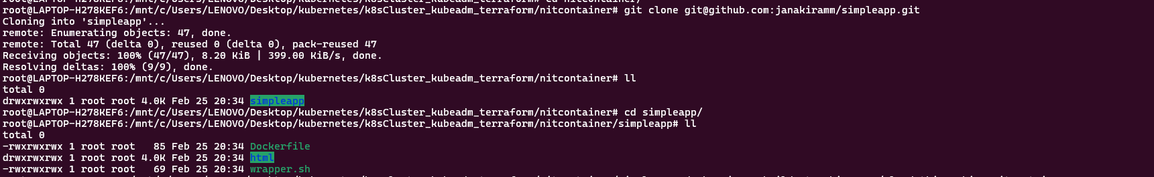

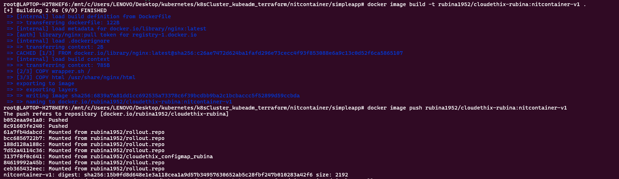

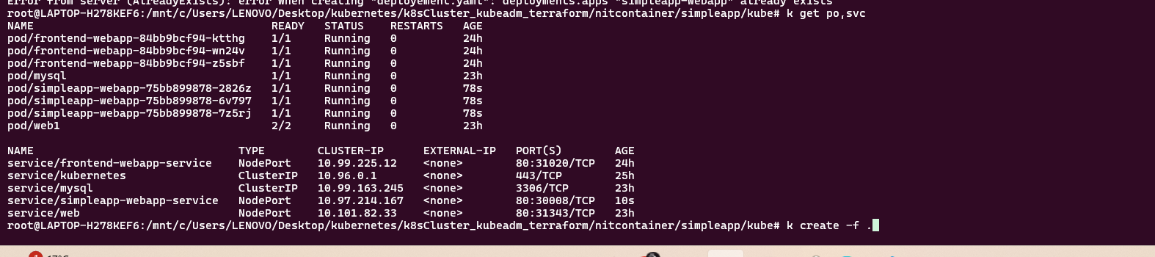

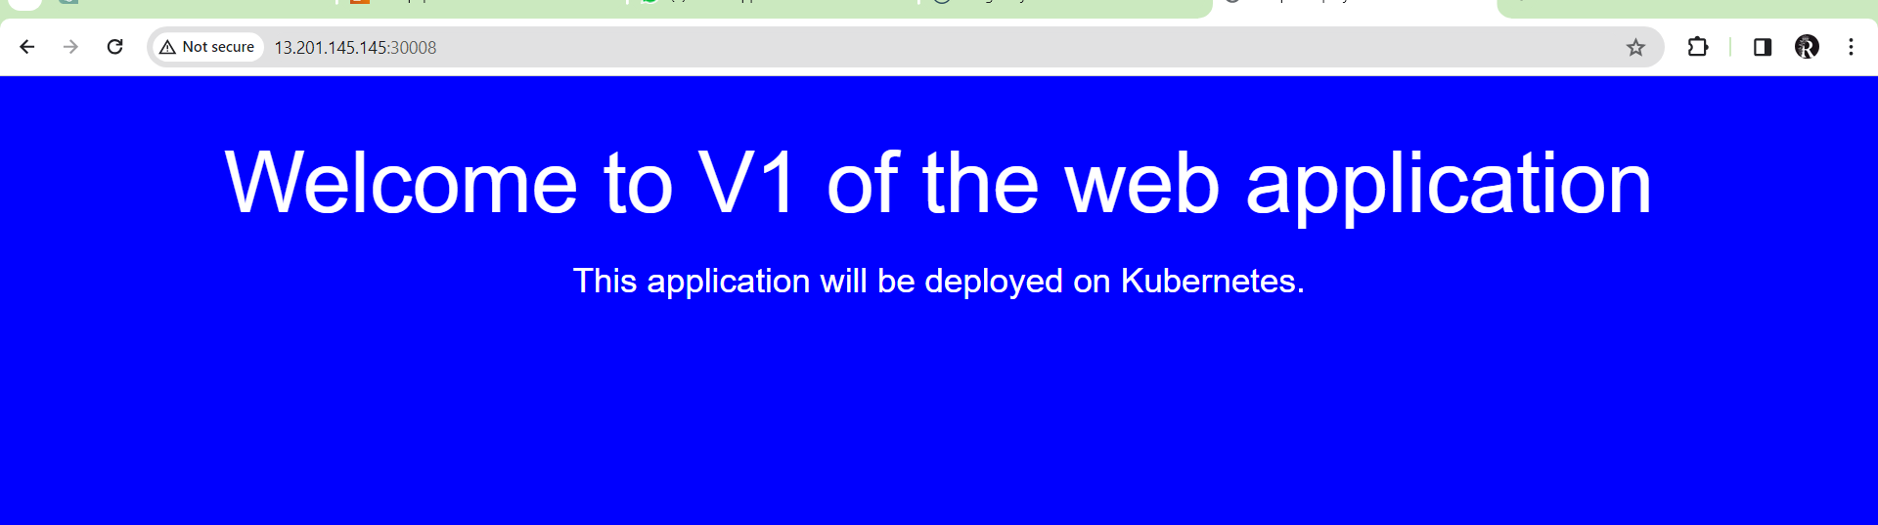

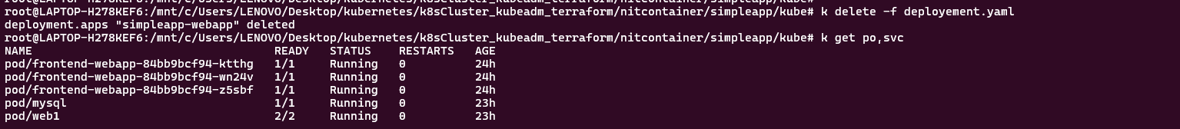

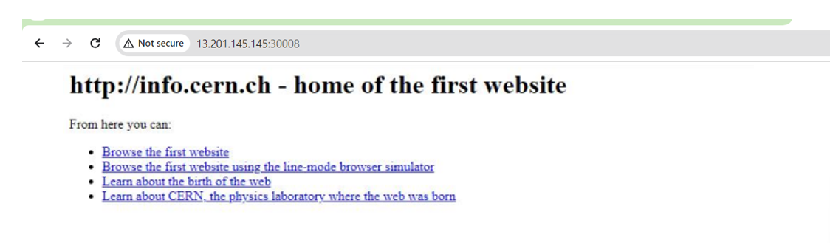

**====================================================================================================**

Que 13 →

● Create 1 Public Docker Hub registry named cloudethix_hpa_yourname. ● Clone below repository on your system. https://github.com/vivekamin/kubernetes-hpa-example.git ● Initialize a local repository & copy the code from above repo to your local repository in any of your working branch. ● Once code is copied , build a docker image from the docker file and add meaningful tags and push to the docker hub repository. ● Once the image is pushed, go to k8s directory and update deployment.yaml file with image name from your repo. And then create it. ● Open service.yml and change the type to nodePort and apply the same. ● Open the HPA.yaml file, notice it and then apply the same. ● Open the browser, and access the webpage. ● Now it's time to test the HPA working with the below command. # kubectl run -i --tty load-generator --rm --image=busybox --restart=Never -- /bin/sh -c "while sleep 0.01; do wget -q -Ohttp://NODE_PORT_SERVICE_NAME; done" ● Check the HPA from kubectl command and also check if the deployment is scaling up. ● Take the snap , prepare a well formatted doc and write your understanding.

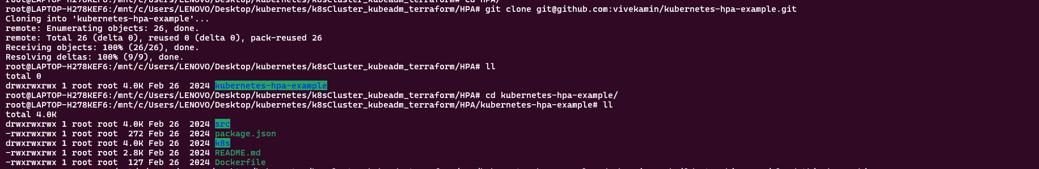

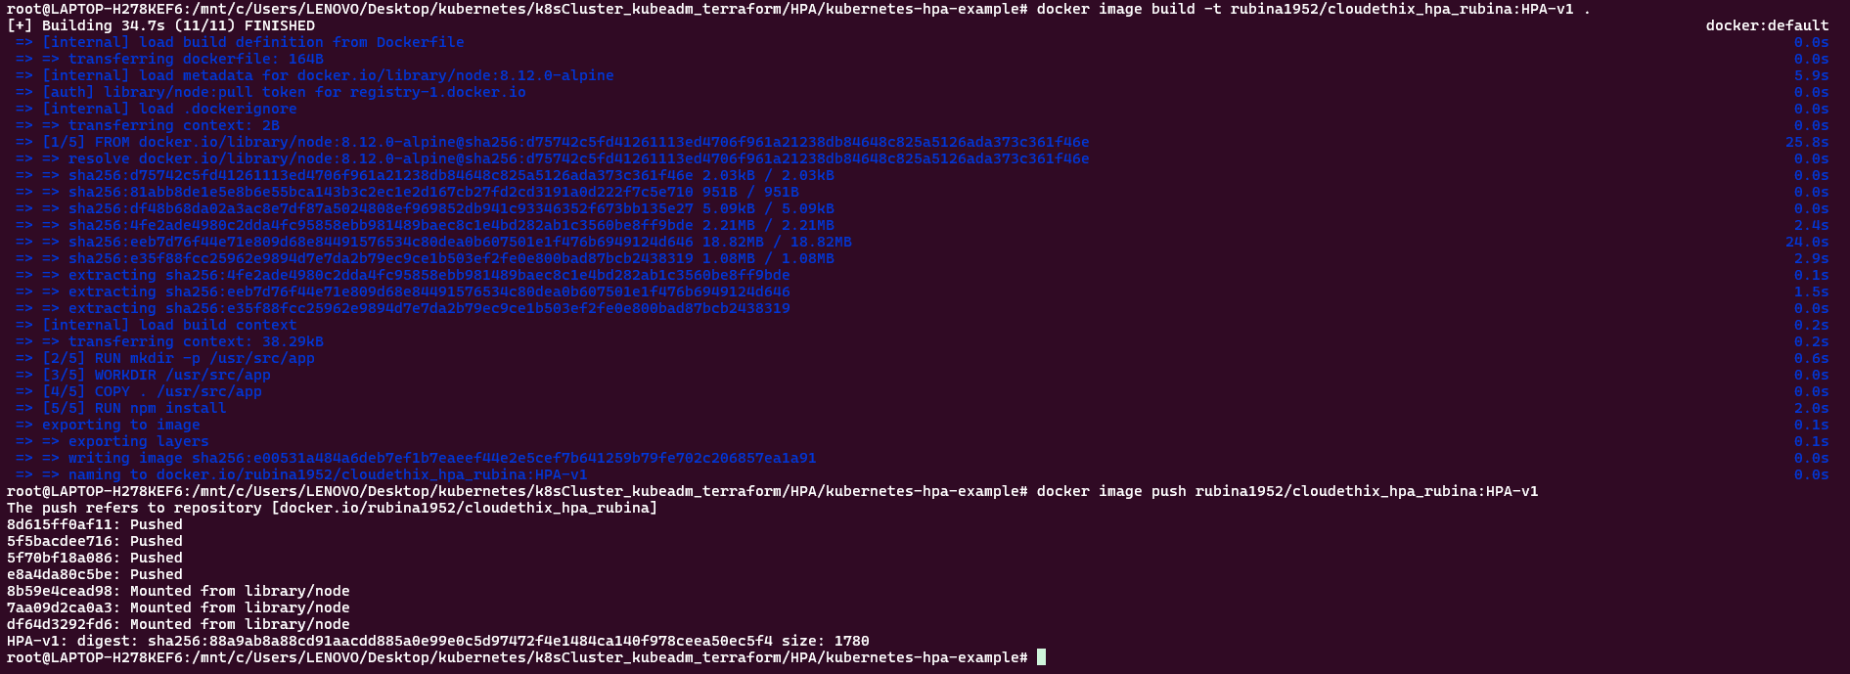

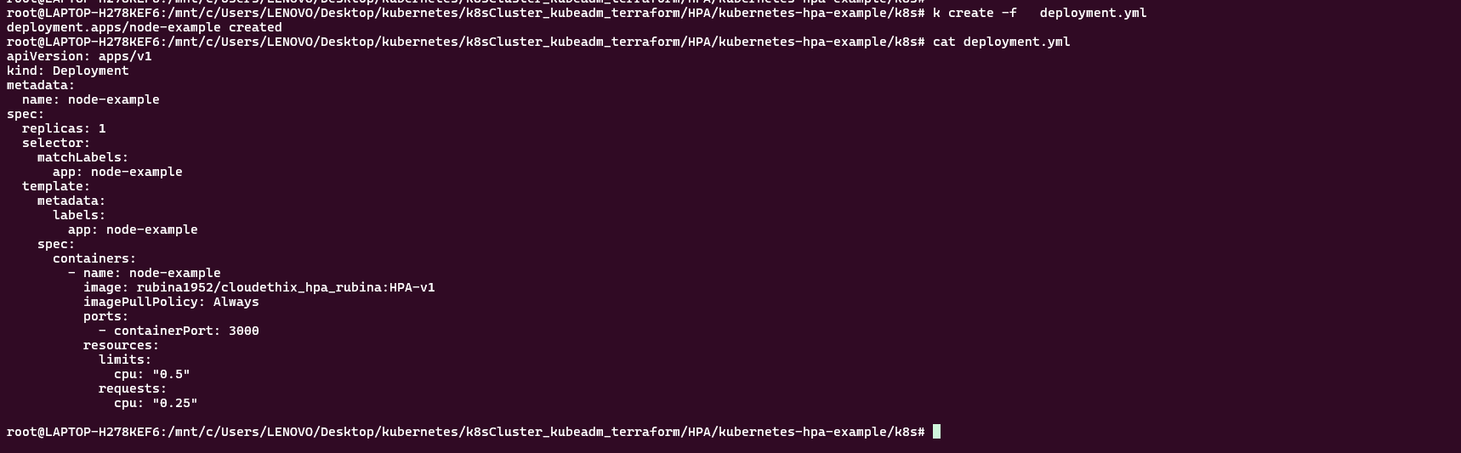

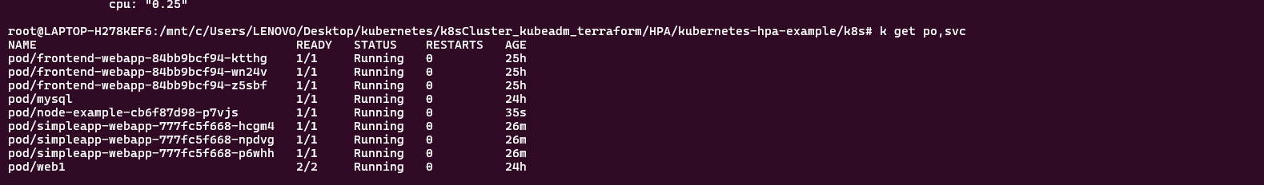

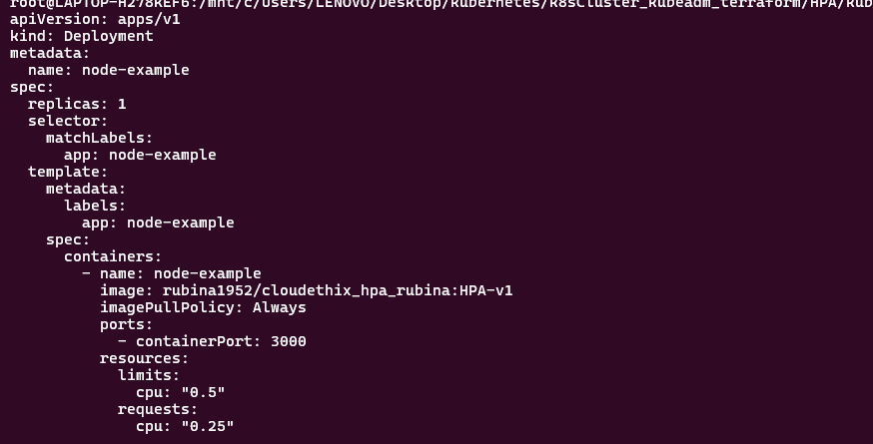

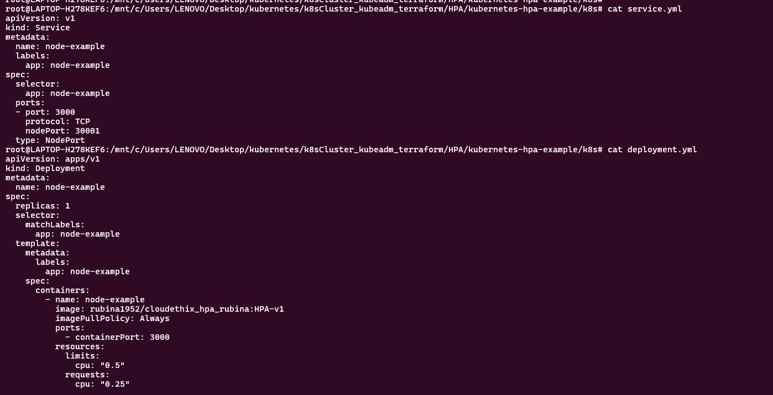

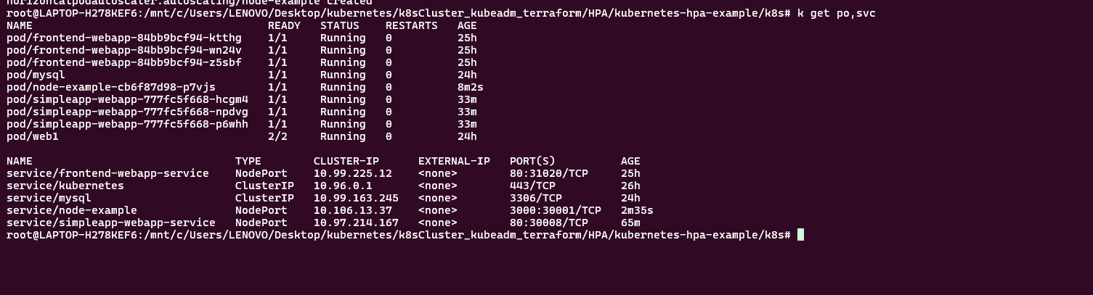

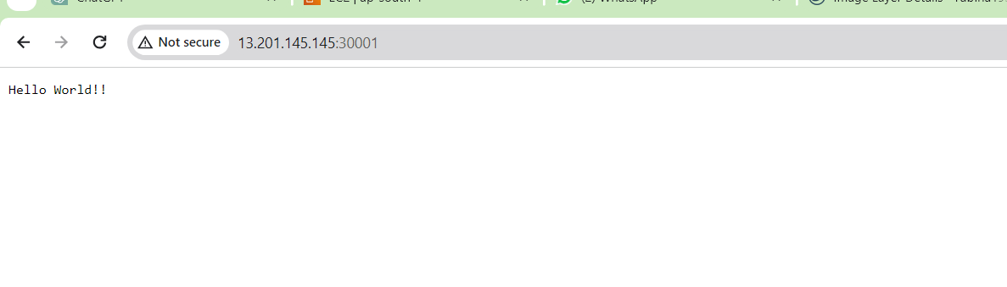

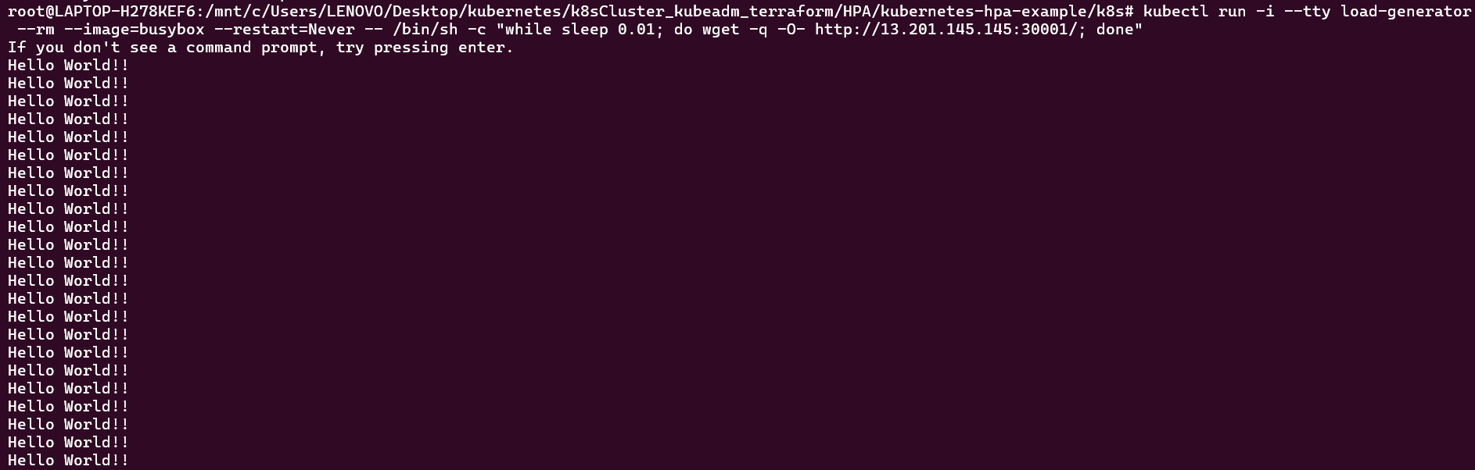

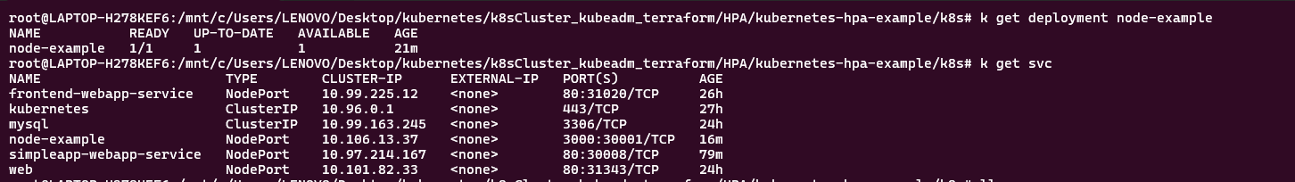

Que 14 → ● Create 1 Public Docker Hub registry named cloudethix_cronjob_yourname. ● Initialize a local repository & copy below code (three files) to your local repository in any of your working branch. ● Once code is copied, build the docker image from Dockerfile , add meaningful tags and then push the docker image to Docker hub registry. ● Now update the pythoncronjob.yml file to change the image name that you have just pushed to docker hub registry. ● Now create a cron job using pythoncronjob.yml file. Check with kubectl command if the cron job is created. ● Check the Job name which is created by cronjob from command line or lens. ● Then check the pod logs which are created by the job and capture the output. ● Prepare well formatted documents and write your understanding.

